**A GPS and Machine Learning Driven Approach to Pothole Detection and Reporting System**

**A PROJECT REPORT**

*Submitted in partial fulfilment of the requirements for the award of the degree of*

***BACHELOR OF TECHNOLOGY***

***In***

**COMPUTER SCIENCE & ENGINEERING**

***by***

K.DEEPTHI (20JR1A0566)

M.LAKSHMI TRIPURA (20JR5A0584)

K.VENKATA SHIVANI (20JR1A0567)

L.SIVANI (20JR1A0580)

*Under the guidance of*

**Mrs.S.VIJAYA LAKSHMI**

Associate Professor, Dept. of CSE

DEPARTMENT OF COMPUTER SCIENCE AND ENGINEERING

**KKR & KSR INSTITUTE OF TECHNOLOGY AND SCIENCES**

(Autonomous)

Vinjanampadu (V), Vatticherukuru (M), Guntur (Dt), A.P-522017.

### JAWAHARLAL NEHRU TECHNOLOGICAL UNIVERSITY KAKINADA :: KAKINADA

**April – 2024**

### CERTIFICATE

This is to certify that this project work titled “ A GPS and Machine Learning Driven Approach to Detection and Reporting System” is the bonafide work of K.Deepthi (20JR1A0566), M.Lakshmi Tripura(20JR1A0584), K.Venkata Shivani(20JR1A0567),

L.Sivani(20JR1A0580) who carried out the work under supervision of Mrs.S.Vijaya Lakshmi and submitted in the partial fulfilment Of the requirements for the award of the degree of BACHELOR OF TECHNOLOGY in COMPUTER SCIENCE & ENGINEERING by KKR & KSR Institute of Technology and Sciences during the academic year 2023-2024.

**SUPERVISOR HEAD OF THE DEPARTMENT**

**PROJECT GUIDE EXTERNAL EXAMINER**

**DECLARATION**

We hereby declare that the project **“A GPS and Machine Learning Driven Approach to Detection and Reporting System*”*** has been carried out by me and this work has been submitted to KKR & KSR Institute of Technology and Sciences (A), Vinjanampadu, affiliated to Jawaharlal Nehru Technological University, Kakinada in partial fulfillment of the requirements for the award of degree of Bachelor of Technology in Computer Science and Engineering.

We further declare that this project work has not been submitted in full or part for the award of any other degree in any other educational institutions.

1. K.DEEPTHI (20JR1A0566)
2. M.LAKSHMI TRIPURA (20JR5A0584)
3. K.VENKATA SHIVANI (20JR1A0567)
4. L.SIVANI (20JR1A0580)

### ACKNOWLEDGEMENT

We would like to express our profound gratitude towards **Mrs.S.Vijaya Lakshmi**,Department of COMPUTER SCIENCE AND ENGINEERING**,** who played a supervisory role to utmost perfection, enabled us to seek through our B.Tech IV-II project - II and for guiding as an internal guide methodically and meticulously.

We express our gratitude towards all the faculty members and non-teaching faculty members, Department of COMPUTER SCIENCE AND ENGINEERING.

We are highly indebted to **Prof. R. RAMESH**, **Head of the Department,** Computer Science and Engineering for providing us all the necessary support.

We render our deep sense of gratitude to **Dr. P. BABU, Principal,** for permitting us to carry out our main project works. We would like to express our sincere thanks to Computer Science and Engineering staff for lending us their time to help us and complete the work successfully.

We are very much thankful to the **college management** for their continuous support and facilities provided. We would also like to thank our staff, parents and friends for their enduring encouragement and assistance whenever required.

**INSTITUTE VISION AND MISSION**

**INSTITUTION VISION**

To produce eminent and ethical Engineers and Managers for society by imparting quality professional education with emphasis on human values and holistic excellence.

**INSTITUTION MISSION**

* To incorporate benchmarked teaching and learning pedagogies in curriculum. • To ensure all round development of students through judicious blend of curricular, co-curricular and extra-curricular activities.
* To support cross-cultural exchange of knowledge between industry and academy.
* To provide higher/continued education and researched opportunities to the employees of the institution.

**DEPARTMENT OF COMPUTER SCIENCE AND ENGINEERING**

### VISION OF THE DEPARTMENT

To become a reputed centre in Computer Science & Engineering for quality, competency and social responsibility.

#### MISSION OF THE DEPARTMENT

* Strengthen the core competence with vibrant technological education in a congenial environment.
* Promote innovate research and development for the economic, social and environment.
* Inculcate professional behaviour, strong ethical values to meet the challenges in collaboration and lifelong learning.

#### Program Specific Outcomes (PSOs)

**PSO1: Application Development**

Able to develop the business solutions through Latest Software Techniques and tools for real time Applications.

**PSO2: Professional and Leadership**

Able to practice the profession with ethical leadership as an entrepreneur through participation in various events like Ideathon, Hackathon, project expos and workshops.

**PSO3: Computing Paradigms**

Ability to identify the evolutionary changes in computing using Data Sciences, Apps, Cloud computing and IoT.

#### Program Educational Objectives (PEOs)

**Graduate of Computer Science and Engineering shall** **PEO 1:**

Domain Knowledge: Have a strong foundation in areas like mathematics, science and them to solve and analyse engineering problems and prepare them to careers, R&D and **PEO 2:**

Professional Employment: Have an ability to analyse and understand the requirements o and provide novel engineering solutions to the problems associated with hardware and s **PEO 3:**

Higher Degrees: Have exposure to cutting edge technologies thereby making them to ach **PEO 4:**

Engineering Citizenship: Work in teams on multi-disciplinary projects with effective co **PEO 5:**

Lifelong Learning: Have a successful career wherein they strike a balance between ethic

|  |
| --- |
| **PROGRAM OUTCOMES (POS)** |
| **1. Engineering knowledge:**  Apply the knowledge of mathematics, science, engineering fundamentals, and an engineering specialization to the solution of complex engineering problems. |
| **2. Problem analysis:**  Identify, formulate, research literature, and analyse complex engineering problems reaching substantiated conclusions using first principles of mathematics, natural sciences, and engineering sciences. |
| **3. Design/development of solutions:**  Design solutions for complex engineering problems and design system components or processes that meet the specified needs with appropriate consideration for the public health and safety, and the cultural, societal, and environmental considerations. |
| **4. Conduct investigations of complex problems:**  Use research-based knowledge and research methods including design of experiments, analysis and interpretation of data, and synthesis of the information to provide valid conclusions. |
| **5. Modern tool usage:**  Create, select, and apply appropriate techniques, resources, and modern engineering and IT tools including prediction and modelling to complex engineering activities with an understanding of the limitations. |
| **6. The engineer and society:**  Apply reasoning informed by the contextual knowledge to assess societal, health, safety, legal and cultural issues and the consequent responsibilities relevant to the professional engineering practice. |
| **7. Environment and sustainability:**  Understand the impact of the professional engineering solutions in societal and environmental contexts, and demonstrate the knowledge of, and need for sustainable development. |
| **8. Ethics:**  Apply ethical principles and commit to professional ethics and responsibilities and norms of the engineering practice. |
| **9. Individual and team work**:  Function effectively as an individual, and as a member or leader in diverse teams, and in multidisciplinary settings. |
| **10. Communication**:  Communicate effectively on complex engineering activities with the engineering community and with society at large, such as, being able to comprehend and write effective reports and design documentation, make effective presentations, and give and receive clear instructions. |
| **11. Project management and finance**:  Demonstrate knowledge and understanding of the engineering and management principles and apply these to one’s own work, as a member and leader in a team, to manage projects and in multidisciplinary environments. |
| **12. Life-long learning**:  Recognize the need for, and have the preparation and ability to engage in independent and life-long learning in the broadest context of technological change. |

**Course Outcomes (COS)**

**CO421.1:** Perform system of examinations to identify problem.

**CO421.2:** Review the literature/Related work.

**CO421.3:** Defining the problem & it's area of domain.

**CO421.4:** Proposal of solution for the selected area/methodology.

**CO421.5:** Analysis of the proposed work & documentation.

**CO421.6:** Acquire collaborative learning, leadership qualities & presentation skills **Course Outcomes Program Outcomes mapping**

|  |  |  |  |  |  |  |  |  |  |  |  |  |  |  |  |
| --- | --- | --- | --- | --- | --- | --- | --- | --- | --- | --- | --- | --- | --- | --- | --- |
|  | **1** | **2** | **3** | **4** | **5** | **6** | **7** | **8** | **9** | **10** | **11** | **12** | **PSO1** | **PSO2** | **PSO3** |
| **CO421.1** | 2 | 3 |  | 2 |  | 2 |  |  |  |  |  |  | 3 |  |  |
| **CO421.2** |  |  |  | 3 | 2 |  | 2 |  |  |  |  |  | 3 |  | 2 |
| **CO421.3** |  | 3 |  |  |  | 2 |  |  | 3 | 3 |  | 1 | 2 |  | 1 |
| **CO421.4** |  |  | 2 |  | 3 | 2 | 2 | 2 |  |  | 1 | 2 | 3 |  | 2 |
| **CO421.5** |  | 2 |  |  | 2 |  |  |  | 2 | 2 |  |  |  | 2 |  |
| **CO421.6** | 1 |  |  |  |  | 2 |  | 2 | 2 | 2 | 2 |  |  | 3 |  |

##### 3: High 2 : Medium 1: Low

**Program Educational Objectives – Program Specific Outcomes correlation**

|  |  |  |  |
| --- | --- | --- | --- |
|  | **PSO1** | **PSO2** | **PSO3** |
| **PEO1** | 2 | 1 | 3 |
| **PEO2** |  | 3 | 2 |
| **PEO3** | 1 | 2 | 3 |
| **PEO4** | 3 |  | 2 |
| **PEO5** | 1 | 3 | 2 |

##### 3: High 2: Medium 1: Low

**CO-PO Mapping with Reasons:**

1. **CO421.1** is mapped with PO1, PO2 and PO4, PO6, PO7 as basic knowledge of Engineering and problem Analysis activities are highly essential to conduct examinations on existing systems which have been using in industries as a part of and to define the problem of proposed system.
2. **CO421.2** is mapped with PO1, PO2, PO4 and PO6, PO9, PO10, PO11 as for identification, gathering analysis and classification of requirements for the proposed system, basic knowledge of engineering and Analysis steps along with complex problem analysis through the efforts of team work in order to meet the specific needs of the customer.
3. **CO421.3** is mapped with PO2, PO5 and PO12 as to conduct the literature review and to examine the relevant systems to understand and identify the merits and demerits of each to enhance and develop the proposed as per the need.
4. **CO421.4** is mapped with PO1, PO2, PO3, PO4, PO5 and PO7, PO8, PO9, PO10 because modularization and design of the project is needed after requirements elicitation. For modularization and design of the project, Basic knowledge of Engineering, Analysis capabilities, Design skills and communication is needed between team members as different modules are designed individually before integration.
5. **CO421.5** is mapped with PO3, PO5, PO7, PO9, PO11 and PO12 as to construct the project latest technologies are needed. The development of project is done individually and in groups with well-defined communication by using the engineering and management principles.
6. **CO421.6** is mapped with PO6, PO10 and PO12 because during and after completion of the project, documentation is needed along with proper methods of presentation through understanding and application of engineering and management principles, which in turn needs well defined communication between the team members with all the ethical values. Even the project development team defines the future enhancements as a part of the project development after identifying the scope of the project.

**CO-PSOs Mapping with Reasons:**

1. **CO421.1** is mapped with **PSO1** as examining of existing systems and identification of the problem is a part of Application Development activity and identification of evolutionary changes in latest technologies.
2. **CO421.2** is mapped with **PSO1, PSO2** and **PSO3**as identifying and classifying the requirements is a part of Application development and evolutionary computing changes and also follows ethical principles.
3. **CO421.3** is mapped with **PSO1, PSO3** as review of literature is a part of application development activity by recognizing the computing technologies and their evolutionary changes.
4. **CO4214** is mapped with **PSO1, PSO3** because modularization and logical design is also a part of Application development and follows computing changes using Deep learning technology.
5. **CO421.5** is mapped with **PSO1, PSO2** as Testing, Development and Integration of project activities are part of Application development and follows ethical principles.
6. **CO421.6** is mapped with **PSO2** as for project documentation and presentation; the project team members apply the professional and leadership quality.

### ABSTRACT

The number of vehicles that are on the road today, whether it is highways or single carriageways, is increasing all the time. Manual detection methods are time-consuming and expensive. Computer vision and machine learning can help automate pothole identification.In addition to preventing accidents due to potholes, landslides, and uneven roads, a road structure safety monitoring system is crucial to ensuring long-term vehicle safety.Pothole detection has become possible as image processing and deep learning technologies have advanced over time.

To overcome this problem, in this paper, focuses on the development of a Machine learning-based pothole detection can detect and classify potholes whether the roads are plain or have potholes early using images which can reduce the chances of an accident and to assist road maintenance personnel in making informed road repair decisions. A customized dataset of potholes are used to build and train a Convolutional Neural Network (CNN) model with the Keras framework.Once trained, the model can identify potholes in photos captured by automobiles. When a car obtains a picture of a pothole, the system uses the trained CNN model to identify and classify it. The pertinent information about the pothole, such as its geographical location and categorization, is then extracted and entered into a database. A customizable website allows users to keep track of the potholes they have reported. Authorities, such as city officials, require a separate login. They can view reported potholes and update their statuses, such as identifying them as fixed.We've also made it simple for authorities to view all reported potholes on a map, allowing them to prioritize where to fix first.

Currently, most pothole detection systems combine machine learning with accelerometer data, but there are few models that rely only on machine learning. By focusing solely on machine learning, this strategy promises to improve road repair, avoid vehicle damage, and make driving safer. Machine learning can analyze large amounts of data to precisely identify and classify potholes, allowing roads to be repaired more quickly. Using these systems can reduce costs, improve roads, and make driving safer. Essentially, applying machine learning is an excellent approach to detect and repair potholes, making roads more pleasant and safer for everyone.

### TABLE OF CONTENTS

**CHAPTERS PAGE NO**

**ABSTRACT** xiii

1. **INTRODUCTION**

1.1 Introduction of the Project 1-3

1.2 Existing System 4

1.3 Proposed System 5-6

1.4 Potential Users 7

1.5 Unique features of the System 7

1.6 Demand for the product 8

1.7 Protection of Idea 9

1. **ANALYSIS** 
   1. Literature Review 10-15
   2. Requirements Analysis 15-16
      1. Functional Requirement Analysis 15
      2. User Requirements 16
      3. Non-Functional Requirements 16
      4. System Requirements 16
   3. Modules Description 17
   4. Feasibility Study 17-18
      1. Technical Feasibility 17
      2. Operational Feasibility 18
      3. Behavioral Feasability 18
   5. Process Model Used 18-20
   6. Hardware and Software Requirements 20-21
   7. SRS Specification 21
   8. Financial Plan for Development of Product 21
   9. Business Plan from seeding to Commercialization 22
      1. Business Model canvas 22

#### 3. DESIGN PHASE

3.1 Design Concepts and Constraints 23-26

3.2 Design Diagram of the System 26-27

3.2.1 Use Case Diagram 26

3.2.2 Class Diagram 27

3.3 Conceptual Design 27-28

3.4 Logical Design 28-31

3.5 Architectural Design 31-32

3.6 Algorithms Design 32-34

3.7 Module Design Specifications 35

#### 4. CODING & OUTPUT SCREENS

4.1 Sample Coding 36-80

4.2 Output Screens 81-86

4.3 Screen Reports 86-87

#### 5. TESTING

5.1 Introduction to testing 88

5.2 Types of Testing 88-91

5.3 Test Cases and Test Reports 92-98

#### 6. IMPLEMENTATION

6.1 Implementation Introduction 99

6.2 Implementation Procedure and Steps 99-100

6.3 User Manual 104

#### 7. CONCLUSION AND FUTURE ENHANCEMENTS

7.1 Conclusion 105

7.2 Future Enhancements 105-106

#### 8. BIBLIOGRAPHY

8.1 Books Referred 107

8.2 Websites Visited 107

8.3 References 108-109

**LIST OF FIGURES**

### FIG NO FIGURE NAME PAGE NO

1. Process of Agile Model 20
2. Business Model canvas 22
3. Use Case Diagram 26
4. Class Diagram 27
5. Sequence Diagram 28
6. Activity Diagram User and Authority 30
7. Colloboration Diagram 31
8. Syatem Architecture 32
9. Data flow Diagram for User and Authority 34
10. Home Page 81
11. Signup Page of User 81
12. Login page of User 82
13. Report Potholes 82
14. Choosing Image 83
15. Image Selection 83
16. Report Status and Location Overview 84
17. Pothole Location on Map 84
18. Authority Login Page 85
19. Updating Status of Pothole 85
20. Status Updated Successfully 85
21. Screen Reports 87
22. VS code Download page 101
23. Terms and Conditions Page 101
24. Visual Studio Setup 102
25. Configuration settings 103
26. Completion of vscode setup 104
27. Home Page Of Visual Studio 104

**LIST OF TABLES**

### TABLE NO TABLE NAME PAGE NO

1. Test case on Login Module of User Data 92
2. Test case on Upload Functionality 93
3. Test Case on Verify Pothole Module 94
4. Test Case on Functionality of Geolocation 95
5. Test case on Functionality of report status 96
6. Test Case on Authority Login Module 97
7. Test Case on Error Handling Module 98

# CHAPTER-1

### INTRODUCTION

#### 1.1 Introduction of the project

After the US, automobile usage is the second largest form of transportation globally in India. The Indian government contributes millions of rupees annually to the construction and maintaining of roads, which is an important cost in the national budget.A nation's infrastructure advancements determine its level of economic success and growth. Infrastructure development has a number of obstacles, yet a well-functioning network is important for business, social mobility, industry, and national communication.

The highway infrastructure should be maintained, and the damages may be the reason for the growing amount of accidents. However, roads inside towns are constructed to be smaller and made up of one or two lanes. Roads are vital in people’s daily life, so periodic maintenance shall be made to keep them functional and safe. The vast majority of the nation's roadways have congestion, have poor surfaces, and have unsatisfied maintenance demands.

Roads have many undesired potholes that are extremely unsafe for commuters due to inadequate road network design and development as well as natural calamities like severe rains. On a daily basis, commuters have to struggle with problems because of awful road conditions. Because of the discomfort, stress, and frustration that traffic congestion affects for everyone, it is crucial to increase awareness of these dangerous driving circumstances. Potholes additionally result in an enormous amount of injury to automobiles. Typical problems involve damage to the suspension, steering, tires and rims, and even the body of the automobile.

Additionally, potholes may cause vehicles to become out of alignment, which may lead to uneven tire wear and an earlier need for replacement. This imposes a significant financial strain on the country's residents. According to the Ministry of Road Transport and Highways, approximately 11300 people died and 29600 were injured in road accidents caused by potholes in 2021, 2022, and 2023. According to UNESCAP, road traffic accidents cost India over 3% of its GDP each year, or approximately USD 58,000 million in absolute terms (as of 2022).

Potholes have a huge influence on roads and communities, ranging from safety concerns to financial constraints. These anomalies endanger automobiles and pedestrians, causing accidents and injuries. Furthermore, potholes inflict considerable damage to vehicles, resulting in costly repairs and delays to daily activities. Potholes can further aggravate traffic congestion by hindering vehicle flow and increasing travel time. Furthermore, potholes lead to infrastructure deterioration, indicating underlying problems with road maintenance and development. Aside from these immediate consequences, potholes can also pose public health risks and harm the local economy. To guarantee safer and more resilient road networks, potholes must be addressed through proactive maintenance initiatives, investment in infrastructure enhancements, and community engagement.

Collaboration among government agencies, research institutions, and technology companies will be critical in driving the acceptance and deployment of machinelearning-based solutions for pothole identification and road repair. Public awareness and education campaigns can be extremely effective in highlighting the benefits of machine learning technologies in road maintenance and encouraging wider use by commuters and authorities.

Furthermore, continuous monitoring and evaluation of the efficacy of machinelearning-based pothole detection systems will be required to discover areas for improvement and optimization. By cultivating an innovative and collaborative culture, India can establish itself as a global leader in the development and implementation of machine-learning-based road maintenance solutions.

The successful application of machine-learning-based pothole detection systems has the potential to transform road repair procedures, not only in India but also in other developing and developed nations facing similar challenges.

As technology advances and improves, there is limitless opportunity for further innovation in the sector of road maintenance, with machine learning playing a critical role in driving growth and change.

Finally, by leveraging machine learning, India can overcome the obstacles posed by decaying road infrastructure, paving the way for safer, more efficient transportation networks that benefit all inhabitants.

Pothole Detection and Reporting Systems (PDRS) are vital instruments for rapidly finding and repairing potholes on roadways. One of the key applications of PDRS is to simplify the process of reporting potholes by allowing users to upload images and define locations using user-friendly interfaces. This facilitates contact between individuals and appropriate agencies, resulting in more prompt repairs and safer road conditions. Furthermore, PDRS provides authorities with crucial information on the number and distribution of potholes, allowing them to prioritize repairs according on severity and location. PDRS improves total road maintenance efficiency by centralizing data and optimizing resource allocation. Furthermore, integrating PDRS with current infrastructure management systems enables real-time monitoring of repair progress and data-driven decision-making.

PDRS represents a paradigm shift in road infrastructure management, leveraging cutting-edge technologies such as computer vision and machine learning to revolutionize the way potholes are detected and addressed. Inspired by the success of CNN in data visualization, PDRS utilizes similar deep learning techniques to intelligently identify and report potholes in real-time.

In order to effectively maintain roadways, maintenance departments must assess their state on a regular basis. This is frequently achieved through yearly inspections or in response to public concerns. Staff travel down the streets inspecting and documenting the conditions, which are subsequently recorded into a database. In any situation, the monitoring is more valuable. To address the aforementioned issues, a cost-effective solution is required. Fundamentally, there is a schism between the people, elected officials, and civic bodies.

## 1.2 Existing System

Existing pothole detection systems use a variety of technologies designed to handle the issues of identifying road imperfections. These methods take a variety of approaches, ranging from traditional statistical feature extraction combined with binary classification algorithms such as Random Forest Tree and KNN to cutting-edge deep learning techniques like YOLO V8 for real-time pothole identification.

YOLO V8 permits the speedy and accurate identification of traffic dangers, hence improving overall road safety. Another novel approach involves using edge recognition algorithms in conjunction with ultrasonic sensors designed specifically for pothole identification. This combination improves the system's ability to detect road faults, resulting in more extensive coverage. Furthermore, some systems include feature extraction from several frequency domains, leveraging classifiers such as Random

Forest to accurately recognize potholes under a variety of road conditions. \

Furthermore, new automatic color picture processing algorithms powered by deep neural networks are used to thoroughly check road surfaces for potholes. Each of these approaches has distinct advantages, whether through the incorporation of data augmentation methods, the creation of lightweight architectures, or the application of advanced discriminating algorithms to distinguish potholes from other road imperfections such as speed bumps. Together, these different technologies strengthen and improve the performance of pothole detecting systems, thereby boosting road safety and maintenance operations.

## 1.3 Proposed System

Our method is intended to make the process of reporting potholes on roadways more convenient for everyone involved. To begin, individuals must create an account, which grants them access to the reporting platform. Once logged in, people can easily upload photographs of potholes they see. They can also specify the exact position of the pothole on a map or allow the system do it automatically. Following the upload, users may keep track of the status of their pothole reports on a dedicated page, ensuring transparency and visibility throughout the process.Authorities in charge of road maintenance can access the system using their own login credentials. They may view all reported potholes and take immediate action to address them.

To detect the pothole we collected a dataset which contains classes of some common type of potholes .The dataset includes 200 real-time images including training, testing and validation subsets. A customized dataset of pothole photos obtained from multiple internet platforms used to build and train a Convolutional Neural Network (CNN) model with the Keras framework. Teachable Machine, a platform with user-friendly interfaces for training machine learning models, is used to assist the training process. Here, they can view all reported potholes and take necessary action to address them promptly. By having access to this information, authorities can efficiently prioritize and allocate resources for pothole repairs, ultimately contributing to safer roads for everyone All data, including user accounts, pothole reports, and their statuses, is safely kept in MongoDB, a dependable database system The pertinent information about the pothole, such as its geographical location and categorization, is then extracted and entered into a database. The data is stored using MongoDB, a NoSQL database management system noted for its flexibility and scalability. MongoDB facilitates the efficient storing and retrieval of pothole-related information. This ensures that information is organized and readily available when needed. By centralizing this data, the system allows for more effective coordination between users and authorities, ensuring that reported potholes are filled in a timely way.

Overall, our solution intends to simplify the pothole reporting and repair procedure, hence improving road safety and infrastructure maintenance efforts. An identification are made using CNN model to detect skin pothole in images.By evaluating the trained model with custom dataset it results in detecting identification of pothoe and reporting the pothole and the updating the status of the pothole.

By focusing solely on machine learning, this strategy promises to improve road repair, avoid vehicle damage, and make driving safer. Machine learning can analyze large amounts of data to precisely identify and classify potholes, allowing roads to be repaired more quickly

## 1.4 Potential Users

In this project, the potential user are to begin, Local governments can utilize insights from the system to effectively prioritize road repairs, focusing on potholes in areas posing the greatest risk to public safety and satisfaction. By improving road conditions, governments enhance overall community well-being and satisfaction with infrastructure maintenance. Moreover, targeted repairs based on real-time data can optimize resource allocation, leading to cost savings and increased efficiency in road maintenance operations

Second, Larger transportation groups can leverage project data to develop comprehensive regional or national road safety initiatives. By analyzing trends and patterns in pothole occurrence, these groups can undertake targeted interventions and distribute resources more efficiently. This proactive approach not only reduces the incidence of accidents but also enhances the overall quality of road travel, improving the experience for commuters and contributing to economic productivity..

Furthermore, Road maintenance companies stand to benefit significantly from the implementation of the project. By harnessing the system's capabilities, these businesses can optimize their operations by identifying and scheduling repairs based on real-time data. This results in better resource allocation, reduced downtime, and increased production, ultimately leading to higher customer satisfaction and improved profitability for maintenance companies.

Furthermore, Integrating pothole detection systems into the development of self-driving automobiles presents an intriguing possibility to enhance vehicle safety and performance. Autonomous vehicle makers can utilize technology to ensure smooth and safe travel on highways, reducing the risk of accidents and damage caused by road defects. By incorporating such systems, manufacturers can enhance the reliability and safety of autonomous vehicles, thereby accelerating their adoption and acceptance in the market.

Insurance companies have a vested interest in the initiative as they can leverage the data to determine risk factors associated with road conditions and adjust insurance prices accordingly. This data-driven approach allows insurers to make more informed decisions, benefiting both the company and its customers. By accurately assessing risk, insurance companies can offer more tailored policies and mitigate potential losses associated with accidents caused by poor road conditions.

Finally, the pothole detecting project benefits daily drivers by reducing bumpy rides and improving road safety. By finding and correcting potholes as soon as possible, the project helps to enhance driving conditions and overall road safety, hence improving the driving experience for all drivers.

## 1.5. Unique features of the System

* The method uses a unique dataset of pothole photos to ensure precise training and improve accuracy.
* Using a CNN allows the algorithm to discern detailed patterns associated with potholes, which improves detection ability.
* By integrating with various platforms, the system streamlines model training and deployment processes, increasing efficiency.
* With real-time detection, the system can quickly locate potholes and take fast action.
* The system can retrieve detailed information on discovered potholes, including their exact location and type, allowing for targeted repairs.
* Integration with MongoDB optimizes storage and management of pothole data, improving accessibility and organization.
* With a user-friendly interface, the system allows for easy interaction and display of findings, fostering smooth communication and decision making.

## 1.6. Demand for the product

The demand for the pothole detecting project originates from the critical need to solve road safety and infrastructure maintenance issues. Potholes offer substantial threats to vehicles, bikers, and pedestrians as roads deteriorate from factors such as weathering and excessive traffic. The initiative fulfills this requirement by providing a proactive system for identifying and prioritizing pothole repairs, resulting in fewer accidents, vehicle damage, and potential liabilities for road authorities.

Additionally, the initiative addresses the increased interest in using technology to improve transportation efficiency and safety. With advances in machine learning and computer vision, there is an increasing demand for novel solutions to age-old problems such as pothole identification. As such, the demand for the project is driven by stakeholders seeking modern.

Furthermore, the project is consistent with broader cultural trends that emphasize sustainability and resource optimization. By enabling targeted repairs based on realtime pothole detection data, the initiative improves road maintenance efficiency while reducing wasteful expenses and environmental problems associated with reactive repair tactics.

Furthermore, the initiative addresses the need for greater data-driven decision-making in governance and infrastructure management. Road authorities who can collect, evaluate, and act on pothole detection data can make more informed judgments about resource allocation, policy planning, and long-term infrastructure improvements. To summarize, the demand for the pothole detection project stems from the critical need to improve road safety, utilize technology for transportation improvements, promote sustainability in infrastructure management, and enable data-driven governance procedures. By meeting these requests, the project provides useful solutions for improving road conditions, increasing public safety, and optimizing infrastructure maintenance.

## 1.7. Protection of Idea

Protecting the idea underlying the pothole detecting project is critical to sustaining its competitive advantage and long-term viability. This can be accomplished through a variety of tactics designed to protect intellectual property and confidential information.

Non-disclosure agreements (NDAs) are critical in guaranteeing that intellectual project details remain confidential when shared with potential partners or investors.

Seeking intellectual property rights, such as patents for novel algorithms or techniques, offers legal protection against unauthorized use or reproduction by competitors. Furthermore, protecting trade secrets, such as proprietary information and software programs, through internal policies and encryption safeguards helps to retain exclusivity. Copyright protection for original project-related information, branding, and trademarks enhances the project's legal defenses against infringement.

Furthermore, contractual arrangements with collaborators or investors .

Seeking intellectual property rights, such as patents for novel algorithms or techniques, offers legal protection against unauthorized use or reproduction by competitors. Furthermore, protecting trade secrets, such as proprietary information and software programs, through internal policies and encryption safeguards helps to retain exclusivity. Copyright protection for original project-related information, branding, and trademarks enhances the project's legal defenses against infringement.

Furthermore, contractual agreements with collaborators and stakeholders should include provisions addressing intellectual property ownership and confidentiality requirements. Finally, monitoring the marketplace for potential infringement and taking legal action as needed helps to enforce protection and dissuade unlawful usage. By effectively executing these tactics, the pothole detecting project's concept can be protected, allowing the project team to maximize its originality and impact.

**CHAPTER - 2** **ANALYSIS PHASE**

**2.1 Literature Review**

[1]Shubhra Rao Kuthyar,Roopashree S,Rasika V,Sahana Manjesh,Priyadarshini has introduced An Intelligent Pothole Detection and Alerting System using Mobile Sensors and Deep Learning developed 2021 IEEE 18th India Council International .The mobile applications are created with Flutter, a cross-platform framework for Android and iOS. Commuters utilize the public app to report potholes in various modes such as trip mode and capture image mode. These modes make use of smartphone accelerometers as well as deep learning techniques like YOLOv3 models. They also have specific features such as alert mode, which alerts the user of nearby potholes while commuting, and geotagging of all potholes spotted by all users. The customized mobile application for Elected Representatives, PWD, and the assigned contractor is designed to track the reporting and progress of pothole repair and to assign the next task in the process.

[2]Ganesh Babu R,Chellaswamy C,Surya Bhupal Rao M,Saravanan M,Department of Electronics and Communication Engineering;"Deep Learning Based Pothole Detection and Reporting System (IEEE 2020) aimed to an accelerometer and ultrasonic sensor were set up in the bottom of a car while moving at a speed of 25 km/h and a GPS was used to determine the location**.** The microcontroller, which also detects the pothole, informs the control room of its location. The microprocessor (ATmega328) initializes the GPS and also provides the coordinates. The methodology used was a comparison of CNN, KNN (k-Nearest Neighbors), and Kirchhoff's Theory Method.

1. Ping Ping ; Xiaohui Yang; Zeyu Gao;"A Deep Learning Approach for Street pothole Detection";2020 IEEE Sixth International Conference on Big Data Computing Service and Applications (BigDataService). proposed a intended to construct an accurate and efficient pothole detecting system by utilizing machine learning and artificial intelligence technologies. Yolo V3(You Only Look Once) Algorithm, SSD(Single Shot Detector) Algorithm, HOG(Histogram of Oriented Gradients) with Support Vector Machine, and Faster R-CNN are four current deep learning models that are trained to see which model or ensemble of models delivers the best results.
2. Shebin Silvister,Dheeraj Komandur,Shubham Kokate,Aditya Khochare,Dr. Vishwanath Karad MIT World Peace University Pune, India;"Deep Learning Approach to Detect Potholes in Real-Time using Smartphone";2019 Introduces a system to detect potholes in real time, a system that uses deep learning algorithms and is integrated with cellphones is used. The customer The system's interface is a smartphone app that maps all potholes along the route the user is taking. At the same time, deep learning object detection algorithm: The Single Shot Multi-box Detector (SSD) searches for potholes in the background using a mobile camera. As soon as an unregistered pothole is spotted by SSD, the coordinates of the pothole are updated in real-time in the database. To detect unregistered potholes, accelerometer and gyroscope signals are continuously collected and analyzed by a Deep Feed Forward Neural Network model. This dual detection system comprising camera-based and accelerometer-gyroscope-based detection not only cross checks detections but also gives steady findings even when one mechanism fails. The pothole coordinates are displayed on the map user interface, which is accessible within the same application

[5]Pothole Detection Using Deep Learning: A Real-Time andAI-on-the-Edge

Perspective:For a real-time pothole detection ,Muhammad Haroon Asad proposed Annotation for each image is performed explicitly after the collection of the dataset.annotated data are split into training and testing data before passing it to deep learningmodels such as the YOLO family and SSD for custom modeltraining. weights obtained after training contribute to model performance evaluation on testing data. customweights are then converted into the OpenVino IR format to perform real-time detection on OAK-D and Raspberry pi as host computer.

[6]Dr.M. Seetha ,Professor and Dr. K. Prasanna,Associate Professor, has India;"Intelligent Deep Learning Based Pothole Detection and Alerting System";International Journal of Computational Intelligence Research Volume 19.provides a deep learning-based technology that can detect potholes early using photographs and videos, lowering the risk of an accident. Faster Region-based Convolutional Neural Network (F-RCNN) and You Only Look Once Version 3 (YOLO V3) are the foundations of this model. It also discusses the difficulties of detecting potholes, such as changing lighting conditions and data noise.

1. Anas Al-Shaghouri, Rami Alkhatib, Samir Berjaoui Chouf 2010, Lebanon;"RealTime Pothole Detection Using Deep Learning" deployed and tested many deep learning architectures for detecting potholes. First, a cellphone mounted on the automobile windshield captures many photographs of potholes. Then, by downloading pothole photographs from the internet, we expanded the quantity and variety of our database (1087 images with over 2000 potholes). Second, several object detection methods are used to detect potholes in road photos. To compare pothole detection performance, real-time Deep Learning algorithms with various configurations such as SSDTensorFlow, YOLOv3-Darknet53, and YOLOv4-CSPDarknet53 are employed..
2. Yeoh Keng Yik, Nurul Ezaila Alias, Yusmeeraz Yusof and Suhaila Isaak in 2010 IEEE sixth eition proposed a Apart from accelerometer detection, image processing, or machine learning-based detection, which are easier to design and deliver more accurate results. When a pothole is identified by a real-time webcam, the position is recorded and visualized using Google Maps API. A total of 330 data sets were sampled for the pothole detecting training model's implementation. As a consequence, the model produced 65.05 mAP, 0.9% precision, and 0.41 recall. The detection limitation of the YOLOv3 method can be improved further by employing GPU with better specified performances that can sample 1000 to 10,000 datasets..

[9]Prof.Arunadevi Khaple(Professor), Shubham Barangule(Student), Nandakishor

More(Student),Omkar Mote(Student), Abhishek Doke:”POTHOLE DETECTION AND COMPLAINT MANAGEMENT SYSTEM USING DEEP LEARNING" 2023.In this paper , proposed system utilizes deep learning techniques to automatically detect potholes in real-time, using a camera mounted on a vehicle. The system employs convolutional neural networks (CNNs) to classify images and identify potholes. It also includes a complaint management module that enables citizens to report potholes using a mobile application, which then sends the location and image of the pothole to the system. The system's backend processes the data received from the camera and the mobile application, and generates reports and alerts for concerned authorities. The system aims to streamline the process of pothole detection and management, enabling prompt repair and maintenance of roads, and improving road safety.

[10] Aparna , Yukti Bhatia, Rachna Rai , Varun Gupta 2023 In this paper, Convolutional neural networks based potholes detection using thermal imaging analyses the feasibility and accuracy of thermal imaging in the field of pothole detection. upon collecting a sufficient amount of data containing images of potholes under various conditions and weather, and implementing augmentation techniques on the data, a convolutional neural networks approach of deep learning, which is a new approach in this problem domain using thermal imaging, was adopted.

[11]Kunal Chawla,Vanshika Kaul,Cse-AI &ML, Chandigarh University,Mathura, India.Parth Thakkar,Shiv Sahil Soni 2023 adapts a StreetSafe: AI-Based Android Application for Pothole Detection This research paper proposes an android application StreetSafe which is an end-to-end pothole detection application, which can be downloaded on any Android based device and which can help to combine all these processes and even save lives of innocent drivers and pedestrians. The methods proposed in this paper are proven to be 97% accurate in detecting these anomalies and alerting the user about these anomalies on the road.

1. Harun Joe,Joseph Blessingh, Joel proposed An Intelligent Pothole Detection System using Deep Learning"; 2020.The research focuses on gathering and evaluating pothole datasets in order to train a convolutional neural network. The tiny YOLOv3 object detection technology is used to detect potholes. A system architecture is identified that can be used to create a mobile application for detecting and displaying a visualized image of potholes and the information can be used by the Municipal Authority to repair the potholes.
2. Prof.Arunadevi Khaple, Shubham Barangule, Nandakishor More,Omkar Mote, Abhishek Doke 2023 survey on pothole detection and complaint management system using deep learning:This survey paper provides an overview of the recent advancements in the pothole detection system using CNNs. The paper discusses the state-of-the-art techniques and their limitations, as well as the challenges and future directions in this field. The survey paper reviews several state-of-the-art techniques in pothole detection using CNNs, including YOLOv4, Faster R-CNN, and Mask R-CNN. The paper also highlights the challenges in this field, including the limited availability of datasets and the need for real-time processing algorithms that can run on low-power devices.
3. Mr K. Krishna Reddy,Tuniki Bhavana,Bandyala Tejaswini, P. Mallesh,Adepu sharath, 2023 A Deep Learning Approach For Pothole Detection".employs standard techniques such as "use of FRCNN" and "inception v2 model," which are detailed further below. The key benefit of this strategy is the short training duration, easy training process, and improved accuracy. The following procedures must be taken in order to obtain a trained and operational Faster R-CNN architecture. -RPN training entails first training the RPN architecture with the dataset so that it can propose the expected region.Fast R-CNN Training - Faster R-CNN, as we know, is a hybrid of RPN and Fast R-CNN. So, in order to create a Faster R-CNN, we must train a Fast R-CNN utilizing the suggestions obtained by RPN (after training). Convolutional layers are being fixed, and unique layers are being fine-tuned to RPN.
4. Shylee Veronica, Poojashree C, Himangshu Das, Mangesh Thakur 2022 proposed a

Pothole Detection System" a system for detecting road potholes using computer vision and deep learning. To identify and locate potholes in the provided data set, we employ the YOLO v5 technique. It is a revolutionary convolutional neural network (CNN) that detects objects with high accuracy in real timeIn the sense that it provides predictions after only one forward propagation run through the neural network, the approach "only looks once" at the image.After non-max suppression (which assures that the object detection algorithm only recognizes each object), it then provides discovered items.

1. Rupsha Debnath, Sayandeep Dutta, Dr. Sangita Roy, Arpita Santra 2023 adapts Real Time Pothole Detection with Deep Learning and Arduino dataset consists of two image sets: normal roads and potholes. The dataset's photos have all been labeled. We took a dataset from Kaggle and trained it with Python Machine learning. The dataset includes 352 photos of typical roads and 329 photographs of potholes.
2. Machine learning based approach for pothole detection : The authors for identification of potholes they considered three types of techniques they are paper based on crowd sourcing technique ,pothole detection technique by capturing data from 2D lidar and cameras ,image processing technique using K-Means clustering technique and considering the most accuracy as final result and placing in a application.
3. A Deep Learning Approach for Street Pothole Detection: The authors propose an efficient pothole detection system using deep learning algorithms which can detect potholes on the road automatically. Four models are trained and tested with preprocessed dataset, including YOLO V3, SSD, HOG with SVM and Faster RCNN.Based on experimental results YOLOv3 is consider as faster and have more reliable detection results.
4. Pothole Detection Using Deep Learning Classification Method:In this proposed system image processing and deep learning technique are used for detection of potholes ctures and video clips. Image processing techniques are used to annotate labels and crop theimages for the dataset. SDD with inception v2 backbone model, RCNN model with inception v2 as backbone andYOLOv3 models are used.Among them YOLOv3 is faster .the data has stored in cloud and displays potholes on road map web application.

[20]Real-Time Pothole Detection Using Machine Learning Techniques: The authors are using parameters obtained from video or image calibration with checkerboard to calculate the disparity map. 2-dimensional image points can be projected to 3dimensional world points using the disparity map. With all the 3-dimensional points, they are using bi-square weighted robust least squares approximation for road surface fitting. All points below the road surface model can be detected as pothole region. The size and depth of each pothole can be obtained as well and by using polling the figuring the pothole with color and placing it in an application created by using python3.

### 2.2 Requirement analysis

Requirement Analysis, also known as Requirement Engineering, is the process of defining user expectations for new software being built or modified. Requirements analysis encompasses those tasks that go into determining the needs or conditions to meet for a new or altered product or project, taking account of the possibly conflicting requirements of the various stakeholders, analyzing, documenting, validating and managing software or system requirements.

#### 2.2.1. Functional requirement analysis

Functional Requirements are the desired operations of a program that specify the behavior. These requirements define the calculations, technical details, data manipulation processing. They mainly define the functionality of the software. It is basic functionalities or desired behaviour document clearly and competitively.

* **Image Recognition and Classification**: The system needs to accurately spot and categorize potholes in pictures taken by vehicles or other devices.
* **Real-time Detection:** The system should quickly find potholes as they're spotted, allowing for instant alerts to be sent to the right people.
* **Integration with Vehicle Sensors:** The system must work smoothly with sensors and tools already in vehicles, like cameras and GPS, to gather data and spot potholes effectively.
* **Database Management:** It should be able to store and manage all pothole data, including location, kind, and severity. This database should make it simple to locate and analyze pothole information as needed.

#### 2.2.2. User requirements

User Requirements are used as the primary input for creating system requirements. These requirements are used for objective and testing of product information.

* **Accessibility**- The user can access the software with through a simple interface whenever he was connected to internet.
* **Security**- The search and login history are totally secured.
* **Usability**- User can use without any issue because of the friendly user interface.

#### 2.2.3. Non-functional requirement analysis

These define the system properties and constraints that arise through user names, because of the needs for interoperability with other software. It is a requirement that specifies criteria can be used to judge the operation of the system, rather than specific behavior.

* **Availability**- The software can be available anytime whenever the user wants to use it.
* **Recoverability**- If user lost login information, the person can request through portal of website and every data is stored in our server.
* **Maintainability**- We maintain our software by receiving feedback & updating software according to user requirements.
* **Performance requirements-** The performance will be fully based on the internet connection. The user may not worry about their local system. The local system will be only used as a terminal.
* **Safety requirements-** There are possibilities of data loss due to the interruption of connection on the internet. So the user must ensure about his uninterrupted internet connection.

#### 2.2.4. System requirements

The system requirements include using a custom dataset to train machine learning algorithms in the Visual Studio Code package. These algorithms will use the acquired data to analyze and forecast patterns. Furthermore, the detected data will be stored in MongoDB for easy management and retrieval.

### 2.3. Module description

It describes the major functionalities of each module.

* **Data collection**- Acquires pothole images from various sources and formats for training and analysis.
* **Analysis**- Utilizes machine learning algorithms to process pothole images, detect potholes, and classify their characteristics.
* **Integration**- Integrates seamlessly with MongoDB for storing pothole data, including location and type, ensuring efficient management and retrieval.

### 2.4. Feasibility Study

A feasibility study is an evaluation of a proposal designed to determine the difficulty in carrying out a designated task. Generally, a feasibility study precedes technical development and project implementation. In other words, a feasibility study is an evaluation or analysis of the potential impact of a proposed project. Preliminary investigation examines project feasibility; the likelihood the system will be useful to the organization. The main objective of the feasibility study is to test Technical, Operational and Behavioral feasibility for adding new modules and debugging old running systems.

* Technical feasibility
* Operational feasibility
* Behavioral feasibility

#### 2.4.1. Technical feasibility

This study is carried out to check the technical feasibility i.e., the technical requirements of the system. Any system developed must not have a high demand on the available technical resources. ‘Evaluating technical feasibility is the trickiest part of a feasibility study. A number of issues have to be considered while doing a technical analysis. The usage of this application over a cloud environment simply needs an uninterrupted and uninterrupted internet connection.

The technical requirements of this project like Operating System support that are related to the end users are affordable by every user. The developer also need not have any advanced knowledge of all our technical aspects. So based on these circumstances we can say that the project supports technical feasibility

#### 2.4.2. Operational feasibility

It is a measure of how well a proposed system solves the problems, and takes advantage of the opportunities identified during scope definition and how it satisfies the requirements identified in the requirements analysis phase of a system development. The proposed system solves all the problems in the existing system on the basis of time, cost, risk, etc.…

In this project all the transactions performed are maintained by the admin (company manager). As the manager will already have enough knowledge, he no longer needs to be trained to utilize the software. In this way this project supports Operational feasibility also.

#### 2.4.3. Behavioral feasibility

Behavioral feasibility is a term used to describe people's attitudes towards different things. It also studies how people react to things. Here we mainly focus on how users react to each and every part of our website. How each and every part of our project helps the user to reach all his requirements.

In our project we are using different algorithms in order to process all the available transactions. We also use other programming languages to provide a flexible interface for the user so that the communication between the user and the company becomes easy.

### 2.5. Process model used

The process model which would be helpful for the development of the proposed system is the agile process model. The Agile model was primarily designed to help a project to adapt to change requests quickly. So, the main aim of the Agile model is to facilitate quick project completion. To accomplish this task agility is required. Agility is achieved by fitting the process to the project, removing activities that may not be essential for a specific project. Also, anything that is a waste of time and effort is avoided. Actually, Agile model refers to a group of development processes. These processes share some basic characteristics but do have certain subtle differences among themselves. **Principles of Agile model:**

* To establish close contact with the customer during development and to gain a clear understanding of various requirements, each Agile project usually includes a customer representative on the team. At the end of each iteration stakeholders and the customer representative review the progress made and re-evaluate the requirements.
* The Agile model relies on working software deployment rather than comprehensive documentation.
* Frequent delivery of incremental versions of the software to the customer representative in intervals of a few of a few weeks.
* Requirement change requests from the customer are encouraged and efficiently incorporated.
* It emphasizes on having efficient team members and enhancing communications among them is given more importance. It is realized that enhanced communication among the development team members can be achieved through face-to-face communication rather than through the exchange of formal documents.
* It is recommended that the development team size should be kept small (5 to 9 peoples) to help the team members meaningfully engage in face-to-face communication and have a collaborative work environment.
* Agile development processes usually deploy Pair Programming. In Pair programming, two programmers work together at one work-station. One does code while the other reviews the code as it is typed in. The two programmers switch their roles every hour or so.

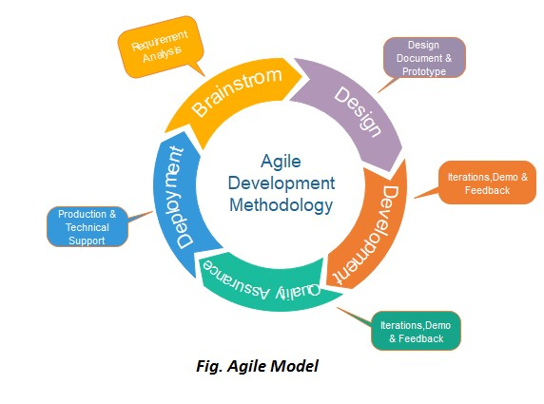

Figure1: Process of Agile Model

Here we gather requirements needed for software development and design the modules & we develop the software with machine learning algorithms which perform predictive operations to find the percentage of all the details in location.

After development phase, beta testing is done to know whether the software is running efficiently or not. If it is working then original software is released for user. The software is maintained by updating it according to user feedback.

### 2.6. Hardware and software requirements

The following are the software and hardware requirements to execute or to implement our project:

### Software Requirements: (for development)

For developing the application, the following are the Software Requirements:

* Visual Studio Code
* Python

### Operating Systems supported: (for end user)

* Windows 7 or higher

**Technologies and Languages used to Develop:**

* Python
* Html
* CSS
* Java Script

**Debugger and Emulator:**

* Any Browser (Particularly Chrome)

**Hardware Requirements:**

For developing the application, the following are the Hardware Requirements:

* Processor: Pentium IV or higher
* RAM: 2 GB
* Space on Hard Disk: minimum 100GB

#### 2.7. SRS Specification

A software requirements specification (SRS) is a description of a software system to be developed. It lays out functional and non-functional requirements, and may include a set of use cases that describe user interactions that the software must provide. Our software will fulfil every requirement needed for the user and concentrates on internal and external requirements in the final system. **Benefits of a good SRS:**

* + You save time
  + You save money
  + You have better cooperation with the development team ● You feel confident

**2.8 Financial Plan for Development of Product :**

* + - Initial Investment: Hardware, software, and infrastructure.
    - Personnel Costs: Development team salaries.
    - Data Acquisition: Funds for relevant datasets.
    - Hardware and Software: Necessary tools costs.
    - Research and Development: Experimentation funds.
    - Quality Assurance: Testing activities budget

**2.9 Business Plan from seeding to Commercialization :**

The business plan is divided into important phases, starting with initial finance and ending with product launch. Starting with seed money, the goal is to secure investment, perform market research, and develop a prototype. Development and testing fine-tune the product based on feedback, followed by a trial deployment for field testing. Scaling and growth boost production and marketing activities, ultimately leading to commercialization. Continuous improvement and expansion are stressed throughout, with an emphasis on consumer input and prospects for diversification

##### 2.9.1 Business Model Canvas

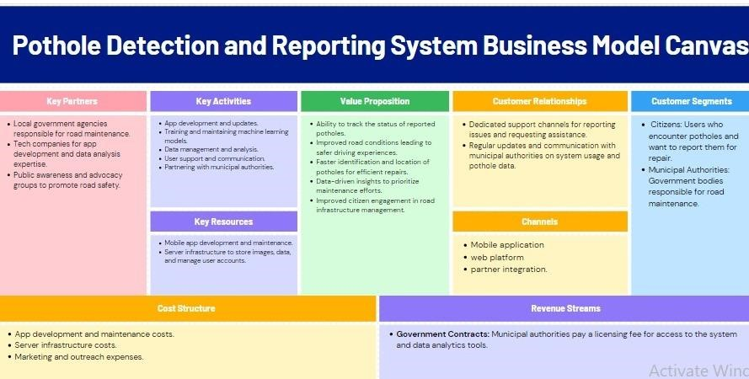

Figure2:Pothole Detection Business Model Canvas

**CHAPTER-3**

**DESIGN PHASE**

**Input design:**

The input design is the link between the information system and the user. It comprises the developing specification and procedures for data preparation and those steps are necessary to put transaction data into a usable form for processing can be achieved by inspecting the computer to read data from a written or printed document or it can occur by having people keying the data directly into the system. The design of input focuses on controlling the amount of input required, controlling the errors, avoiding delay, avoiding extra steps and keeping the process simple. The input is designed in such a way that it provides security and ease of use while retaining privacy. Input Design considered the following things:

* What data should be given as input?
* How should the data be arranged or coded?
* The dialog to guide the operating personnel in providing input.
* Methods for preparing input validations and steps to follow when error occurs.

**Output design:**

A quality output is one, which meets the requirements of the end user and presents the information clearly. In any system results of processing are communicated to the users and to other systems through outputs. In output design it is determined how the information is to be displaced for immediate need and also the hard copy output. It is the most important and direct source information to the user. Efficient and intelligent output design improves the system’s relationship to help user decision-making.

**3.1. Design concepts & Constraints**

The set of fundamental software design concepts are as follows:

### 1. Abstraction

A solution is stated in large terms using the language of the problem environment at the highest-level abstraction. The lower level of abstraction provides a more detail description of the solution. A collection of data that describes a data object is a data abstraction.

### 2. Architecture

The complex structure of the software is known as software architecture. Structure provides conceptual integrity for a system in a number of ways and the architecture is nothing but the structure of program modules where they interact with each other in a specialized way.

### 3. Patterns

A design pattern describes a design structure and that structure solves a particular design problem in a specified content. Design patterns helps to solve a particular design problem.

### 4. Modularity

Software is separately divided into name and addressable components and sometimes they are called as modules which integrate to satisfy the problem requirements. It is a single attribute of software that permits a program to be managed easily.

### 5. Information hiding

Modules must be specified and designed so that the information like algorithm and data in a module is not accessible for other modules not requiring that information.

### 6. Functional independence

The functional independence is the concept of separation and related to the concepts of modularity, abstraction and information hiding. It can be accessed by using two criteria **i) Cohesion**

A cohesive module performs a single task and it requires a small interaction with the other components in other parts of the program.

### ii) Coupling

Coupling is an indication of interconnection between modules in a structure of software. **7. Refinement**

A hierarchy is established by decomposing a statement of function in a stepwise manner till the programming language statements are reached. And it follows top-down design approach.

### 8. Refactoring

Refactoring is the process of changing the software system in a way that it does not change the external behavior of the code but still improves the internal structure. It simplifies the design components without changing its function behavior.

### 9. Design classes

The model of software is defined as a set of design classes. Every class describes the elements of problem domain and that focus on features of the problem which are user visible

### Design Constraints

Design constraints are the limitations of a design. These include imposed limitations that you don’t control and limitations that are self-imposed as a way to improve design.

There are several types of design constraints and they are as follows

**1. Commercial constraints**

In this we consider the basic commercial requirements such as time and budget.

### 2. Requirements

In the requirements phase we consider the functional requirements of a system and they specify the results of a system.

1. **Non-functional requirements**

Requirements that specify intangible elements of a design.

1. **Compliance**

Compliance to applicable laws, regulations and standards.

### 5. Style

A style guide or multiple style guides related to an organization, brand, product, service, environment or project. For example, a product development team may follow a style guide for a brand family that constraints the colors and layout of package designs.

### 6. Sensory design

Beyond visual design, constraints may apply to taste, touch, sound and smell. For example, a brand identity that calls for products to smell fruity.

1. **Usability**

Usability concentrates on principles, frameworks and standards.

1. **Principles**

It illustrates the design principles of an organization, team or individual.

### 9. Integration

A design that needs to work with other things such as products, services, systems, processes, controls, partners and information.

#### 3.2 Design Diagram of the System

A design diagram of a system should typically contain the following components:

1. Use case diagram: A representation of user interactions with the system.
2. Class diagram: A representation of the classes, objects, and relationships in the system.

##### 3.2.1 Use case diagram

Use case diagram at its simplest is a representation of a user’s interaction with the system that shows the relationship between the user and the different use cases in which the user is involved. A use case diagram can identify the different types of users of a system and the different use cases and will often be accompanied.

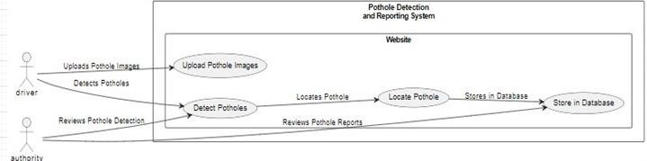

Figure 3: Representation of use case diagram for User and Authority

##### 3.2.2 Class diagram

Class diagram in the Unified Modeling Language (UML) is a type of static structure diagram that describes the structure of a system by showing the system's classes, their attributes, operations (or methods), and the relationships among objects.

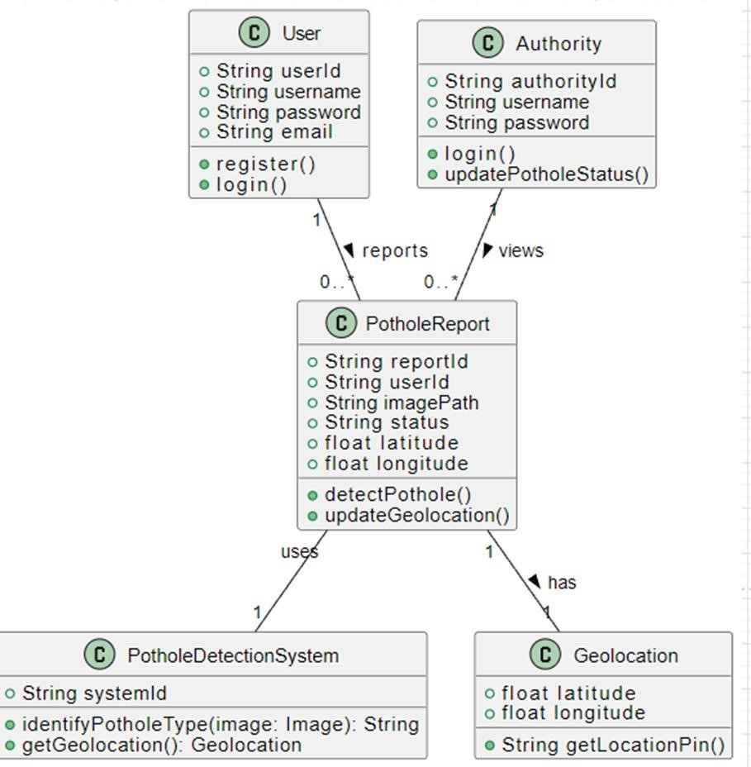

Figure 4: Representation of Class diagram

#### 3.3 Conceptual Design

Conceptual designis an early phase of the design process, in which the broad outlines of function and form of something are articulated. It includes the design of interactions, experiences, processes and strategies. It involves an understanding of people's needs - and how to meet them with products, services, & processes. Common artifacts of conceptual design are concept sketches and models.

#### 3.4. Logical Design

The logical designof a system pertains to an abstract representation of the data flows, inputs and outputs of the system. This is often conducted via modeling, using an over-abstract and sometimes graphical model of the actual system.

### Sequence diagram

A Sequence diagramshows object interactions arranged in time sequence. It depicts the objects and classes involved in the scenario and the sequence of messages exchanged between the objects needed to carry out the functionality of the scenario.

Sequence diagrams are typically associated with use case realizations in the Logical View of the system under development.

Sequence diagrams are sometimes called event diagrams or event scenarios.

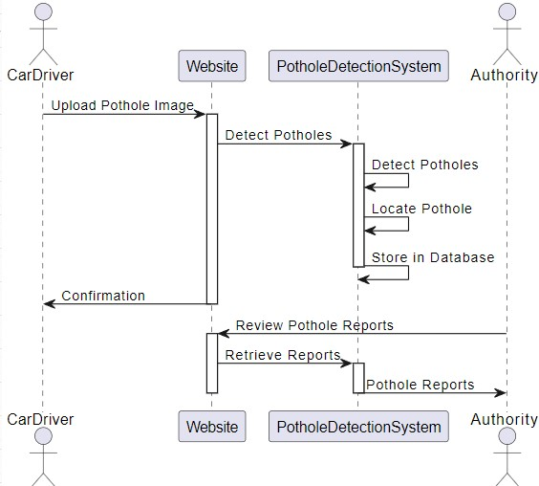

Figure 5: Representation of sequence diagram

### Activity diagram

Activity diagramsare graphical representations of workflows of stepwise activities and actions with support for choice, iteration and concurrency.

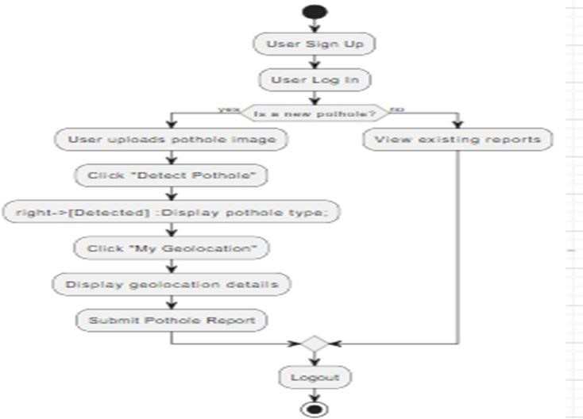

Figure 6: Representation of Activity diagram for user

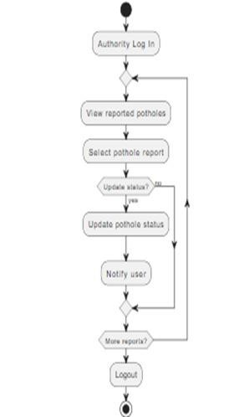

Figure 7: Representation of Activity diagram for Authority

### Collaboration diagram

A Collaboration diagrammodels the interactions between objects or parts in terms of sequenced messages. Communication diagrams represent a combination of information taken from Class, Sequence, and Use Case Diagrams describing both the static structure and dynamic behavior of a system.

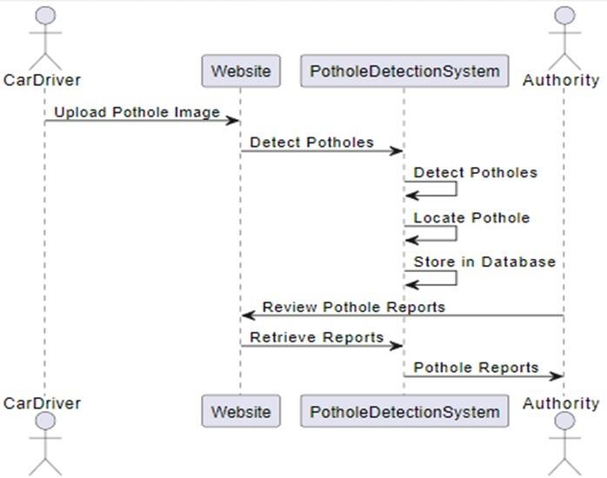

Figure 8: Representation of Collaboration diagram

#### 3.5. Architectural Design

Architectural design isa concept that focuses on components or elements of a structure any changes the client wants to make to the design should be communicated to the architect during this phase.

Flow diagramis a collective term for a diagram representing a flow or set of dynamic relationships in a system.

A data flow diagram(DFD) is a way of representing a flow of a data of a process or a system, usually an information system. The DFD also provides information about the outputs and inputs of each entity and the process itself.

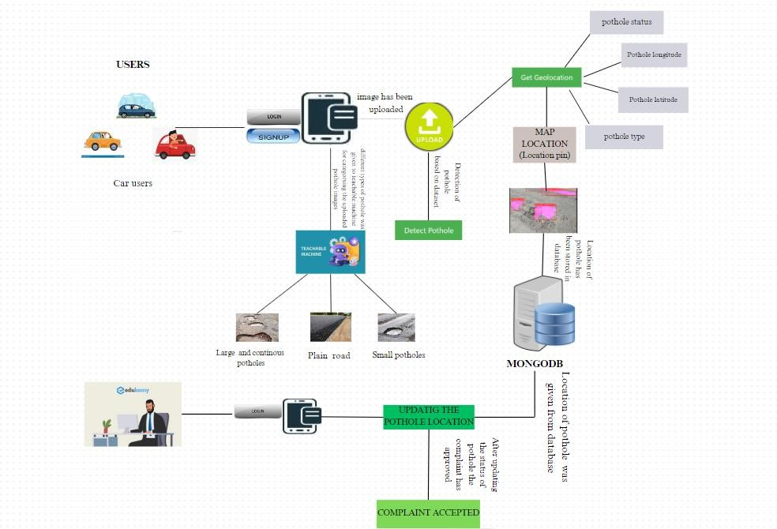

Figure 9: System architecture of Pothole Detection and Reporting System

**3.6. Algorithms Design Algorithm for user:**

**Steps:**

1. Start.
2. Open the Pothole Detection Application.
3. Capture an image of the road surface using the camera feature.
4. Preprocess the captured image to enhance features and remove noise.
5. Extract relevant features from the preprocessed image.
6. Apply a machine learning model to the extracted features to detect potholes.
7. Classify the detected potholes based on their type or severity.
8. Store information about the detected potholes, including location and classification.
9. Notify relevant authorities or users about the detected potholes, if necessary.
10. View the results of the pothole detection process.
11. Logout.
12. Stop.

**Algorithm for Authority:**

**Steps:**

1. Start.
2. Check reported potholes.
3. Assess severity and location.
4. Prioritize based on safety impact.
5. Assign repair tasks.
6. Update pothole status.
7. Coordinate with maintenance teams.
8. Monitor repair progress.
9. Inform users about updates.
10. Review analytics.
11. Stop.

**Dataflow diagram:**

A data-flow diagram (DFD) is a way of representing the flow of a data of a process or a system. The DFD also provides information about the outputs and inputs of each entity and the process itself. A data-flow diagram has no control flow, there are no decision rules and no loops. Specific operations based on the data can be represented by a flowchart.

**Components of a Data flow diagram:**

The different components of it are:

**Process:**

The process is part of a system that transforms inputs to outputs. The symbol of a process is a circle, an oval, a rectangle or a rectangle with rounded corners.

**Data Flow:**

Data flow shows the transfer of information from one part of the system to another. The symbol of the flow is the arrow.

**Warehouse:**

The warehouse is used to store data for later use. The symbol of the store is two horizontal lines.

**Terminator:**

The Terminator is an external entity that communicates with the system and stands outside of the system.

**Data Flow Diagram:**

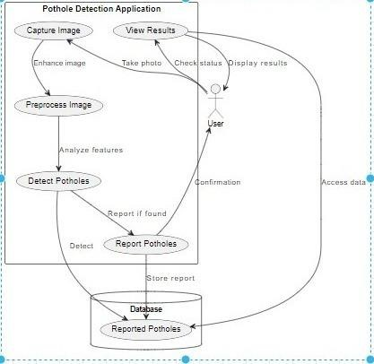

Figure 10: Representation of Data flow diagram for User

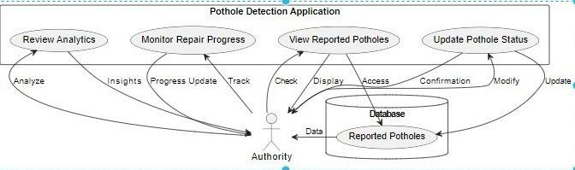

Figure 11: Representation of Data flow diagram for Authority

### 3.7 MODULE DESIGN SPECIFICATIONS

A module design specification contains information about an individual module. It details the aims and learning outcomes of the module, in addition to the teaching, learning and assessment methods. The main goal is to provide specifications sufficiency precise and complete that other pieces of software can be interactive with the specified without additional information.

1.Image Capture Module: Captures photos of the road surface using onboard vehicle cameras or external sensors.

2.The Pothole Detection Module uses machine learning techniques to evaluate collected photos and predict potential potholes based on visual criteria.

1. Data Storage Module: Stores observed pothole data, including attributes like location, kind, and severity, in a MongoDB database for further retrieval and analysis.
2. User Interface Module: Provides a user-friendly interface for dealing with the system, including the ability to display detected potholes and associated information, as well as access system settings and controls.
3. Notification Module: Sends messages to relevant stakeholders, such as road maintenance authorities or vehicle operators, when potholes are detected, allowing for timely action to alleviate road hazards.

6.Data Analysis Module: Analyzes recorded pothole data to discover trends, patterns, and places with high pothole density, which aids in strategic road maintenance planning and decision making.

7. System Integration Module: Allows for the integration of the pothole detecting system with existing car systems, such as navigation and telematics, to improve overall functionality.

**CHAPTER – 4**

**CODING & OUTPUT SCREENS**

### 4.1 SAMPLE CODING

The sample coding phase of an application typically involves writing code that implements the design and functionality of the application based on the specifications and requirements gathered during the planning and design phase.

#### #Frontend Home.html

<!DOCTYPE html>

<html lang="en">

<head>

<meta charset="UTF-8">

<meta name="viewport" content="width=device-width, initial-scale=1.0">

<title>Pothole Detection</title>

<link rel="stylesheet" href="https://stackpath.bootstrapcdn.com/bootstrap/4.5.2/css/bootstrap.min.css" integrity="sha384-

JcKb8q3iqJ61gNV9KGb8thSsNjpSL0n8PARn9HuZOnIxN0hoP+VmmDGMN5t9UJ

0Z" crossorigin="anonymous">

<style> body { background-color: #f1f1f1; font-family: 'Roboto', sans-serif;

}

.navbar { background-color: #3f51b5; border-radius: 0; border: none;

}

.navbar-brand {

font-weight: bold; color: #fff; font-size: 1.5rem;

}

.navbar-nav .nav-link { color: #fff; padding: 0.5rem 1rem; font-size: 1rem; border-radius: 0; transition: all 0.3s ease;

}

.navbar-nav .nav-link:hover { background-color: #fff; color: #3f51b5;

}

.navbar-toggler-icon { color: #fff; }

.jumbotron { background-color: #fff; padding: 3rem 1rem; border-radius: 0; margin-top: 2rem; box-shadow: 0 2px 5px rgba(0, 0, 0, 0.1);

}

.jumbotron h1 { font-weight: bold; color: #3f51b5;

}

.jumbotron p { color: #333;

}

</style>

</head>

<body>

<!-- Navigation bar -->

<nav class="navbar navbar-expand-lg navbar-light bg-light">

<a class="navbar-brand" href="/">Pothole Detection</a>

<button class="navbar-toggler" type="button" data-toggle="collapse" datatarget="#navbarNav" aria-controls="navbarNav" aria-expanded="false" arialabel="Toggle navigation">

<span class="navbar-toggler-icon"></span>

</button>

<div class="collapse navbar-collapse" id="navbarNav">

<ul class="navbar-nav">

<li class="nav-item active">

<a class="nav-link" href="/">Home</a>

</li>

<li class="nav-item">

<a class="nav-link" href="/signup">Signup</a>

</li>

<li class="nav-item">

<a class="nav-link" href="/login">Login</a>

</li>

<li class="nav-item">

<a class="nav-link" href="/authority_login">Authority Login</a>

</li>

</ul>

</div>

</nav>

<!-- Content section -->

<div class="container mt-4">

<div class="row">

<div class="col-md-8 offset-md-2">

<div class="jumbotron">

<h1>Why Pothole Detection Matters</h1>

<p>Potholes on roads pose significant risks to both motorists and pedestrians alike. They can lead to accidents, vehicle damage, and even serious injuries. Here's why pothole detection and timely repair are crucial:</p>

<ul>

<li><strong>Road Safety:</strong> Potholes create hazards for drivers, cyclists, and pedestrians, increasing the likelihood of accidents and injuries.</li>

<li><strong>Vehicle Damage:</strong> Potholes can cause extensive damage to vehicles, including tire punctures, wheel misalignment, and suspension damage, resulting in costly repairs.</li>

<li><strong>Economic Impact:</strong> Poor road conditions due to potholes can affect local economies by deterring tourism, hindering transportation of goods, and increasing vehicle operating costs.</li>

<li><strong>Infrastructure Maintenance:</strong> Timely identification and repair of potholes are essential for maintaining the integrity and longevity of road infrastructure, reducing overall maintenance costs in the long run.</li>

</ul>

<h1>Why Citizen Participation is Vital</h1>

<p>Citizens play a crucial role in helping government authorities identify and address potholes efficiently. Here are some reasons why citizen involvement is essential:</p>

<ul>

<li><strong>Local Knowledge:</strong> Citizens have firsthand knowledge of road conditions in their communities and can quickly identify potholes that may go unnoticed by authorities.</li>

<li><strong>Timely Reporting:</strong> Citizen reports enable authorities to prioritize and address pothole repairs promptly, minimizing risks and inconveniences for road users.</li>

<li><strong>Community Engagement:</strong> Involving citizens in pothole detection fosters a sense of community ownership and encourages collaboration between residents and government agencies to improve road safety and infrastructure.</li>

<li><strong>Efficient Resource Allocation:</strong> By leveraging citizen reports, government agencies can allocate resources more efficiently, targeting areas with the most pressing pothole issues.</li>

</ul>

</div>

</div>

</div>

</div>

</body>

</html>

#### index.html

<!-- templates/index.html -->

<!DOCTYPE html>

<html lang="en">

<head>

<meta charset="UTF-8">

<meta name="viewport" content="width=device-width, initial-scale=1.0"> <title>Pothole Detection</title>

<link rel="stylesheet" type="text/css" href="{{ url_for('static', filename='styles.css') }}">

<link rel="stylesheet" href="https://stackpath.bootstrapcdn.com/bootstrap/4.5.2/css/bootstrap.min.css">

<script src="https://code.jquery.com/jquery-3.5.1.slim.min.js"></script>

<script src="https://cdn.jsdelivr.net/npm/@popperjs/core@2.5.4/dist/umd/popper.min.js"></s cript>

<script src="https://stackpath.bootstrapcdn.com/bootstrap/4.5.2/js/bootstrap.min.js"></script>

<script>

function getLocation() { if (navigator.geolocation) {

navigator.geolocation.getCurrentPosition(sendPosition);

} else {

alert("Geolocation is not supported by this browser.");

}

}

function sendPosition(position) { var latitude = position.coords.latitude;

var longitude = position.coords.longitude;

// Send latitude to Python server var xhr = new XMLHttpRequest(); xhr.open("POST", "/receive_location", true); xhr.setRequestHeader("Content-Type", "application/json"); xhr.onreadystatechange = function () { if (xhr.readyState === 4 && xhr.status === 200) {

console.log("Location sent successfully");

}

};

xhr.send(JSON.stringify({latitude: latitude,longitude:longitude}));

}

</script> <style> body {

font-family: 'Segoe UI', Tahoma, Geneva, Verdana, sans-serif; background-color: #2e92cc;

margin: 0; padding: 0; /* display: flex; */ justify-content: center; align-items: center; height: 100vh;

}

form {

background-color: #ffffff; padding: 20px; border-radius: 8px;

box-shadow: 0 0 20px rgba(0, 0, 0, 0.1); width: 400px; margin-top:100px; margin-left:600px; text-align: center;

}

h2 {

color: #2ea4cc;

}

label { display: block; margin: 10px 0; color: #555;

}

input {

width: calc(100% - 16px); padding: 8px; margin-bottom: 16px; box-sizing: border-box; border: 1px solid #ccc; border-radius: 4px; font-size: 14px;

}

input[type="submit"] { background-color: #2e9fcc;

color: white; cursor: pointer;

transition: background-color 0.3s ease;

}

input[type="submit"]:hover { background-color: #278eae;

}

p { color: #777;

margin-top: 10px;

}

a {

color: #2e9dcc; text-decoration: none;

font-weight: bold;

}

a:hover {

text-decoration: underline;

}</style>

</head>

<body>

<nav class="navbar navbar-expand-lg navbar-light bg-light">

<a class="navbar-brand" href="/">Pothole Detection</a>

<button class="navbar-toggler" type="button" data-toggle="collapse" datatarget="#navbarNav" aria-controls="navbarNav" aria-expanded="false" arialabel="Toggle navigation">

<span class="navbar-toggler-icon"></span>

</button>

<div class="collapse navbar-collapse" id="navbarNav">

<ul class="navbar-nav">

<li class="nav-item active">

<a class="nav-link" href="/dashboard">Home</a>

</li>

<li class="nav-item">

<a class="nav-link" href="/mypotholes">My PotHoles</a>

</li>

<li class="nav-item">

<a class="nav-link" href="/logout">Logout</a>

</li>

</ul>

</div>

</nav>

<form action="/upload" method="post" enctype="multipart/form-data">

<h2>Classifier</h2>

<input type="file" name="image" accept="image/*" required> <br/>

<button type="button" onclick="getLocation()">Get Geolocation</button>

<input type="hidden" name="latitude" id="latitude" value="">

<input type="hidden" name="longitude" id="longitude" value="">

<button type="submit">Detect Pothole</button> <br/> <br/><br/><br/>

<span style="color:green">{{res}}</span>

<span style="color:red">{{error}}</span>

</form>

</body>

</html>

##### LOGIN.HTML

<!DOCTYPE html>

<html lang="en">

<head>

<meta charset="UTF-8">

<meta name="viewport" content="width=device-width, initial-scale=1.0">

<title>Login</title>

<link rel="stylesheet"

href="https://stackpath.bootstrapcdn.com/bootstrap/4.5.2/css/bootstrap.min.css">

<script src="https://code.jquery.com/jquery-3.5.1.slim.min.js"></script>

<script

src="https://cdn.jsdelivr.net/npm/@popperjs/core@2.5.4/dist/umd/popper.min.js"></s cript>

<script src="https://stackpath.bootstrapcdn.com/bootstrap/4.5.2/js/bootstrap.min.js"></script>

<style> body { font-family: 'Segoe UI', Tahoma, Geneva, Verdana, sans-serif; background-color: #2e92cc; margin: 0; padding: 0; /* display: flex; */ justify-content: center; align-items: center; height: 100vh;

}

form { background-color: #ffffff; padding: 20px; border-radius: 8px; box-shadow: 0 0 20px rgba(0, 0, 0, 0.1); width: 400px; margin-top:100px; margin-left:600px; text-align: center;

}

h2 {

color: #2ea4cc;

}

label { display: block; margin: 10px 0; color: #555;

}

input { width: calc(100% - 16px); padding: 8px; margin-bottom: 16px; box-sizing: border-box; border: 1px solid #ccc; border-radius: 4px; font-size: 14px;

}

input[type="submit"] { background-color: #2e9fcc; color: white; cursor: pointer; transition: background-color 0.3s ease;

}

input[type="submit"]:hover { background-color: #278eae;

} p { color: #777; margin-top: 10px;

} a { color: #2e9dcc; text-decoration: none; font-weight: bold;

}

a:hover { text-decoration: underline;

}

</style>

</head>

<body>

<nav class="navbar navbar-expand-lg navbar-light bg-light">

<a class="navbar-brand" href="/">Pothole Detection</a>

<button class="navbar-toggler" type="button" data-toggle="collapse" datatarget="#navbarNav" aria-controls="navbarNav" aria-expanded="false" arialabel="Toggle navigation">

<span class="navbar-toggler-icon"></span>

</button>

<div class="collapse navbar-collapse" id="navbarNav">

<ul class="navbar-nav">

<li class="nav-item">

<a class="nav-link" href="/">Home</a>

</li>

<li class="nav-item">

<a class="nav-link" href="/signup">Signup</a>

</li>

<li class="nav-item active">

<a class="nav-link" href="/login">Login</a>

</li>

<li class="nav-item">

<a class="nav-link" href="/authority_login">Authority Login</a>

</li>

</ul>

</div>

</nav>

<form action="/loginform" method="post">

<h2>Login</h2>

<label for="username">Username</label>

<input type="text" id="username" name="username" required>

<label for="password">Password</label>

<input type="password" id="password" name="password" required>

<input type="submit" value="Login">

<p>Don't have an account yet? <a href='/signup'>Sign Up</a></p>

<span style="color:red">{{err}}</span>

<span style="color:green">{{res}}</span>

</form>

</body>

</html>

##### MYPOTHOLES.HTML

<!-- templates/index.html -->

<!DOCTYPE html>

<html lang="en">

<head>

<meta charset="UTF-8">

<meta name="viewport" content="width=device-width, initial-scale=1.0"> <title>Pothole Detection</title>

<link rel="stylesheet" type="text/css" href="{{ url_for('static', filename='styles.css') }}">

<link rel="stylesheet" href="https://stackpath.bootstrapcdn.com/bootstrap/4.5.2/css/bootstrap.min.css">

<script src="https://code.jquery.com/jquery-3.5.1.slim.min.js"></script>

<script src="https://cdn.jsdelivr.net/npm/@popperjs/core@2.5.4/dist/umd/popper.min.js"></s cript>

<script src="https://stackpath.bootstrapcdn.com/bootstrap/4.5.2/js/bootstrap.min.js"></script>

<script>

function getLocation() {

if (navigator.geolocation) {

navigator.geolocation.getCurrentPosition(sendPosition);

} else {

alert("Geolocation is not supported by this browser.");

}

}

function sendPosition(position) { var latitude = position.coords.latitude;

var longitude = position.coords.longitude;

// Send latitude to Python server var xhr = new XMLHttpRequest(); xhr.open("POST", "/receive_location", true); xhr.setRequestHeader("Content-Type", "application/json"); xhr.onreadystatechange = function () { if (xhr.readyState === 4 && xhr.status === 200) { console.log("Location sent successfully");

}

};

xhr.send(JSON.stringify({latitude: latitude,longitude:longitude}));

}

</script> <style> body {

font-family: 'Segoe UI', Tahoma, Geneva, Verdana, sans-serif; background-color: #2e92cc;

margin: 0; padding: 0; /* display: flex; */ justify-content: center; align-items: center;

height: 100vh;

}

.form {

background-color: #ffffff; padding: 20px; border-radius: 8px;

box-shadow: 0 0 20px rgba(0, 0, 0, 0.1); width: 2000px; margin-top:100px; margin-left:100px; text-align: center;

}

h2 {

color: #2ea4cc;

}

label { display: block; margin: 10px 0; color: #555;

}

input {

width: calc(100% - 16px); padding: 8px; margin-bottom: 16px; box-sizing: border-box; border: 1px solid #ccc; border-radius: 4px; font-size: 14px;

}

input[type="submit"] { background-color: #2e9fcc;

color: white; cursor: pointer;

transition: background-color 0.3s ease;

}

input[type="submit"]:hover {

background-color: #278eae;

}

p { color: #777; margin-top: 10px;

} a { color: #2e9dcc; text-decoration: none; font-weight: bold;

}

a:hover {

text-decoration: underline;

}</style>

</head>

<body>

<nav class="navbar navbar-expand-lg navbar-light bg-light">

<a class="navbar-brand" href="/">Pothole Detection</a> <button class="navbar-toggler" type="button" data-toggle="collapse" datatarget="#navbarNav" aria-controls="navbarNav" aria-expanded="false" arialabel="Toggle navigation">

<span class="navbar-toggler-icon"></span>

</button>

<div class="collapse navbar-collapse" id="navbarNav">

<ul class="navbar-nav">

<li class="nav-item">

<a class="nav-link" href="/dashboard">Home</a>

</li>

<li class="nav-item active">

<a class="nav-link" href="/mypotholes">My PotHoles</a>

</li>

<li class="nav-item">

<a class="nav-link" href="/logout">Logout</a>

</li>

</ul>

</div>

</nav>

<div class="form col-sm-8">

<h2>My Potholes</h2>

<table class="table">

<tr>

<th>S.No</th>

<th>Pot Hole latitude</th>

<th>Pot Hole Longitude</th>

<th>Pot Hole Status</th>

<th>Pot Hole Image</th>

<th>Pot Hole Type</th>

<th>Map Location</th>

</tr>

{% for i in range(l) %}

<tr>

<td>{{ i+1 }}</td>

<td>{{ dashboard_data[i][0] }}</td>

<td>{{ dashboard_data[i][1] }}</td>

<td>{{ dashboard_data[i][2] }}</td>

<td><img height="100" width="100" src="{{ url_for('static',

filename=dashboard_data[i][3]) }}" /></td>

<td>{{ dashboard_data[i][4] }}</td>

<td><a

href="https://google.com/maps?q={{dashboard_data[i][0]}},{{dashboard_data[i][1]}

}" target="_blank">Location Pin</a></td>

</tr>

{% endfor %}

</table>

</div>

</body>

</html>

##### RESULT.HTML

<!-- result.html -->

<!DOCTYPE html>

<html lang="en">

<head>

<meta charset="UTF-8">

<meta name="viewport" content="width=device-width, initial-scale=1.0">

<title>Result</title>

<link rel="stylesheet" type="text/css" href="{{ url_for('static', filename='styles.css') }}">

<link rel="stylesheet" href="https://stackpath.bootstrapcdn.com/bootstrap/4.5.2/css/bootstrap.min.css">

<script src="https://code.jquery.com/jquery-3.5.1.slim.min.js"></script>

<script src="https://cdn.jsdelivr.net/npm/@popperjs/core@2.5.4/dist/umd/popper.min.js"></s cript> <script src="https://stackpath.bootstrapcdn.com/bootstrap/4.5.2/js/bootstrap.min.js"></script>

<style> body {

font-family: 'Segoe UI', Tahoma, Geneva, Verdana, sans-serif; background-color: #2e92cc;

margin: 0; padding: 0; /* display: flex; */ justify-content: center; align-items: center;

height: 100vh;

}

form {

background-color: #ffffff; padding: 20px; border-radius: 8px;

box-shadow: 0 0 20px rgba(0, 0, 0, 0.1);

width: 400px; margin-top:100px; margin-left:600px; text-align: center;

}

h2 {

color: #2ea4cc;

}

label { display: block; margin: 10px 0; color: #555;

}

input { width: calc(100% - 16px); padding: 8px; margin-bottom: 16px; box-sizing: border-box; border: 1px solid #ccc; border-radius: 4px;

font-size: 14px;

}

input[type="submit"] { background-color: #2e9fcc; color: white; cursor: pointer;

transition: background-color 0.3s ease;

}

input[type="submit"]:hover { background-color: #278eae;

} p { color: #777;

margin-top: 10px;

}

a { color: #2e9dcc; text-decoration: none;

font-weight: bold;

}

a:hover { text-decoration: underline; }</style>

</head>

<body>

<nav class="navbar navbar-expand-lg navbar-light bg-light">

<a class="navbar-brand" href="/">Pothole Detection</a>

<button class="navbar-toggler" type="button" data-toggle="collapse" datatarget="#navbarNav" aria-controls="navbarNav" aria-expanded="false" arialabel="Toggle navigation">

<span class="navbar-toggler-icon"></span>

</button>

<div class="collapse navbar-collapse" id="navbarNav">

<ul class="navbar-nav">

<li class="nav-item active">

<a class="nav-link" href="/dashboard">Home</a>

</li>

<li class="nav-item">

<a class="nav-link" href="/mypotholes">My PotHoles</a>

</li>

<li class="nav-item">

<a class="nav-link" href="/logout">Logout</a>

</li>

</ul>

</div>

</nav> <form>

{% if pothole_detected %}

<h1>Pothole Detected!</h1>

<p>Geolocation: {{ geolocation }}</p>

<!-- <img src="{{ modified_image_path }}" alt="Modified Image"> -->

{% else %}

<h1>No Pothole Detected</h1>

<p>Geolocation: {{ geolocation }}</p>

{% endif %}

</form>

</body>

</html>

##### SIGNUP.HTML

<!DOCTYPE html>

<html lang="en">

<head>

<meta charset="UTF-8">

<meta name="viewport" content="width=device-width, initial-scale=1.0">

<title>Sign In</title>

<link rel="stylesheet"

href="https://stackpath.bootstrapcdn.com/bootstrap/4.5.2/css/bootstrap.min.css">

<script src="https://code.jquery.com/jquery-3.5.1.slim.min.js"></script>

<script src="https://cdn.jsdelivr.net/npm/@popperjs/core@2.5.4/dist/umd/popper.min.js"></s cript>

<script src="https://stackpath.bootstrapcdn.com/bootstrap/4.5.2/js/bootstrap.min.js"></script>

<style> body { font-family: 'Segoe UI', Tahoma, Geneva, Verdana, sans-serif; background-color: #2e92cc; margin: 0; padding: 0;

/* display: inline; */ justify-content: center; align-items: center; height: 100vh;

}

form {

/* display: in; */ background-color: #ffffff; padding: 20px; border-radius: 8px; margin-left:600px; margin-top: 100px; box-shadow: 0 0 20px rgba(0, 0, 0, 0.1); width: 400px; text-align: center;

}

h2 { color: #2ea4cc;

}

label { display: block; margin: 10px 0; color: #555;

}

input { width: calc(100% - 16px); padding: 8px; margin-bottom: 16px; box-sizing: border-box; border: 1px solid #ccc; border-radius: 4px; font-size: 14px;

}

input[type="submit"] { background-color: #2e9fcc; color: white; cursor: pointer; transition: background-color 0.3s ease;

}

input[type="submit"]:hover { background-color: #278eae;

} p { color: #777; margin-top: 10px; } a { color: #2e9dcc; text-decoration: none; font-weight: bold;

}

a:hover { text-decoration: underline;

}

</style>

</head>

<body>

<nav class="navbar navbar-expand-lg navbar-light bg-light">

<a class="navbar-brand" href="/">Pothole Detection</a>

<button class="navbar-toggler" type="button" data-toggle="collapse" datatarget="#navbarNav" aria-controls="navbarNav" aria-expanded="false" arialabel="Toggle navigation">

<span class="navbar-toggler-icon"></span>

</button>

<div class="collapse navbar-collapse" id="navbarNav">

<ul class="navbar-nav">

<li class="nav-item">

<a class="nav-link" href="/">Home</a>

</li>

<li class="nav-item active">

<a class="nav-link" href="/signup">Signup</a>

</li>

<li class="nav-item">

<a class="nav-link" href="/login">Login</a>

</li>

<li class="nav-item">

<a class="nav-link" href="/authority_login">Authority Login</a>

</li>

</ul>

</div>

</nav>

<form action="/signupform" method="post">

<h2>Sign Up</h2>

<label for="username">Username</label>

<input type="text" id="username" name="username" required>

<label for="email">Email</label>

<input type="email" id="email" name="email" required>

<label for="password">Password</label>

<input type="password" id="password" name="password" required>

<input type="submit" value="Sign Up">

<p>Already have an account? Go to <a href='/login'>Login</a></p>

<span style="color:red">{{err}}</span>

<span style="color:green">{{res}}</span>

</form>

</body>

</html>

##### UPDATEPOTHOLE.HTML

<!-- templates/index.html -->

<!DOCTYPE html>

<html lang="en">

<head>

<meta charset="UTF-8">

<meta name="viewport" content="width=device-width, initial-scale=1.0"> <title>Pothole Detection</title>

<link rel="stylesheet" type="text/css" href="{{ url_for('static', filename='styles.css')

}}">

<link rel="stylesheet"

href="https://stackpath.bootstrapcdn.com/bootstrap/4.5.2/css/bootstrap.min.css">

<script src="https://code.jquery.com/jquery-3.5.1.slim.min.js"></script>

<script src="https://cdn.jsdelivr.net/npm/@popperjs/core@2.5.4/dist/umd/popper.min.js"></s crip>

<script src="https://stackpath.bootstrapcdn.com/bootstrap/4.5.2/js/bootstrap.min.js"></script>

<script> function getLocation() { if (navigator.geolocation) { navigator.geolocation.getCurrentPosition(sendPosition);

} else { alert("Geolocation is not supported by this browser.");

}

}

function sendPosition(position) { var latitude = position.coords.latitude; var longitude = position.coords.longitude // Send latitude to Python server var xhr = new XMLHttpRequest(); xhr.open("POST", "/receive_location", true); xhr.setRequestHeader("Content-Type", "application/json"); xhr.onreadystatechange = function () { if (xhr.readyState === 4 && xhr.status === 200) { console.log("Location sent successfully");

}

};

xhr.send(JSON.stringify({latitude: latitude,longitude:longitude}));

}

</script> <style> body { font-family: 'Segoe UI', Tahoma, Geneva, Verdana, sans-serif; background-color: #2e92cc; margin: 0; padding: 0; /* display: flex; */ justify-content: center; align-items: center; height: 100vh;

}

.form { background-color: #ffffff; padding: 20px; border-radius: 8px; box-shadow: 0 0 20px rgba(0, 0, 0, 0.1); width: 2000px; margin-top:100px; margin-left:200px; text-align: center;

}

h2 { color: #2ea4cc;

}

label { display: block; margin: 10px 0; color: #555;

}

input { width: calc(100% - 16px); padding: 8px; margin-bottom: 16px; box-sizing: border-box; border: 1px solid #ccc; border-radius: 4px; font-size: 14px;

}

input[type="submit"] { background-color: #2e9fcc; color: white; cursor: pointer; transition: background-color 0.3s ease;

}

input[type="submit"]:hover { background-color: #278eae;

}

p { color: #777; margin-top: 10px;

} a { color: #2e9dcc; text-decoration: none; font-weight: bold;

}

a:hover { text-decoration: underline;

}</style>

</head>

<body>

<nav class="navbar navbar-expand-lg navbar-light bg-light">

<a class="navbar-brand" href="/">Pothole Detection</a>

<button class="navbar-toggler" type="button" data-toggle="collapse" datatarget="#navbarNav" aria-controls="navbarNav" aria-expanded="false" arialabel="Toggle navigation">

<span class="navbar-toggler-icon"></span>

</button>

<div class="collapse navbar-collapse" id="navbarNav">

<ul class="navbar-nav">

<li class="nav-item active">

<a class="nav-link" href="/adashboard">Home</a>

</li>

<li class="nav-item">

<a class="nav-link" href="/updatepothole">Update Pothole</a>

</li>

<li class="nav-item">

<a class="nav-link" href="/logout">Logout</a>

</li>

</ul>

</div>

</nav>

<div class="form col-sm-4">

<h3>Update Pot Holes</h3>

<form action="/updatepotholeform" method="POST">

<div class="form-group">

<label for="sel1">Select Pot Hole:</label>

<select class="form-control" id="potholeid" name='potholeid' required>

{%for i in range(0, l)%}

<option

value={{dashboard_data[i][0]}}>{{dashboard_data[i][0]}}</option>

{%endfor%}

</select>

<label>Select Status:</label>

<select class="form-control" id="potholestatus" name='potholestatus'>

<option value="1">Complaint Accepted</option>

<option value="2">In Processing</option>

<option value="3">Complaint Closed</option>

</select>

</div>

<button type="submit" class="btn btn-primary">Update PotHole</button> <br/>

<span style="color:blue">{{result}}</span>

</form>

</div>

</body>

</html>

##### ADASHBOATD.HTML

<!-- templates/index.html -->

<!DOCTYPE html>

<html lang="en">

<head>

<meta charset="UTF-8">

<meta name="viewport" content="width=device-width, initial-scale=1.0"> <title>Pothole Detection</title>

<link rel="stylesheet" type="text/css" href="{{ url_for('static', filename='styles.css')

}}">

<link rel="stylesheet"

href="https://stackpath.bootstrapcdn.com/bootstrap/4.5.2/css/bootstrap.min.css">

<script src="https://code.jquery.com/jquery-3.5.1.slim.min.js"></script>

<script src="https://cdn.jsdelivr.net/npm/@popperjs/core@2.5.4/dist/umd/popper.min.js"></s cript>

<script src="https://stackpath.bootstrapcdn.com/bootstrap/4.5.2/js/bootstrap.min.js"></script>

<script> function getLocation() { if (navigator.geolocation) { navigator.geolocation.getCurrentPosition(sendPosition);

} else { alert("Geolocation is not supported by this browser.");

}

}

function sendPosition(position) { var latitude = position.coords.latitude; var longitude = position.coords.longitude;

// Send latitude to Python server var xhr = new XMLHttpRequest(); xhr.open("POST", "/receive_location", true); xhr.setRequestHeader("Content-Type", "application/json"); xhr.onreadystatechange = function () { if (xhr.readyState === 4 && xhr.status === 200) { console.log("Location sent successfully");

}

};

xhr.send(JSON.stringify({latitude: latitude,longitude:longitude}));

}

</script> <style> body { font-family: 'Segoe UI', Tahoma, Geneva, Verdana, sans-serif; background-color: #2e92cc; margin: 0; padding: 0; /* display: flex; */ justify-content: center; align-items: center; height: 100vh;

}

.form { background-color: #ffffff; padding: 20px; border-radius: 8px; box-shadow: 0 0 20px rgba(0, 0, 0, 0.1); width: 2000px; margin-top:100px; margin-left:100px; text-align: center;

}

h2 { color: #2ea4cc;

}

label { display: block; margin: 10px 0; color: #555;

}

input { width: calc(100% - 16px); padding: 8px; margin-bottom: 16px; box-sizing: border-box; border: 1px solid #ccc; border-radius: 4px; font-size: 14px;

}

input[type="submit"] { background-color: #2e9fcc; color: white; cursor: pointer; transition: background-color 0.3s ease;

}

input[type="submit"]:hover { background-color: #278eae;

}

p { color: #777; margin-top: 10px;

} a { color: #2e9dcc; text-decoration: none; font-weight: bold;

}

a:hover { text-decoration: underline;

}</style>

</head>

<body>

<nav class="navbar navbar-expand-lg navbar-light bg-light">

<a class="navbar-brand" href="/">Pothole Detection</a>

<button class="navbar-toggler" type="button" data-toggle="collapse" datatarget="#navbarNav" aria-controls="navbarNav" aria-expanded="false" arialabel="Toggle navigation">

<span class="navbar-toggler-icon"></span>

</button>

<div class="collapse navbar-collapse" id="navbarNav">

<ul class="navbar-nav">

<li class="nav-item active">

<a class="nav-link" href="/adashboard">Home</a>

</li>

<li class="nav-item">

<a class="nav-link" href="/updatepothole">Update Pothole</a>

</li>

<li class="nav-item">

<a class="nav-link" href="/logout">Logout</a>

</li>

</ul>

</div>

</nav>

<div class="form col-sm-8">

<h2>Complained Potholes</h2>

<table class="table">

<tr>

<th>S.No</th>

<th>Pot Hole latitude</th>

<th>Pot Hole Longitude</th>

<th>Pot Hole Status</th>

<th>Pot Hole Image</th>

<th>Pot Hole Type</th>

<th>Map Location</th>

</tr>

{% for i in range(l) %}

<tr>

<td>{{ i+1 }}</td>

<td>{{ dashboard_data[i][0] }}</td>

<td>{{ dashboard_data[i][1] }}</td>

<td>{{ dashboard_data[i][2] }}</td>

<td><img height="100" width="100" src="{{ url_for('static', filename=dashboard_data[i][3]) }}" /></td>

<td>{{ dashboard_data[i][4] }}</td>

<td><a

href="https://google.com/maps?q={{dashboard_data[i][0]}},{{dashboard_data[i][1]}}

" target="_blank">Location Pin</a></td>

</tr>

{% endfor %}

</table>

</div>

</body>

</html>

##### ALOGIN.HTML

<!DOCTYPE html>

<html lang="en">

<head>

<meta charset="UTF-8">

<meta name="viewport" content="width=device-width, initial-scale=1.0">

<title>Login</title> <link rel="stylesheet"

href="https://stackpath.bootstrapcdn.com/bootstrap/4.5.2/css/bootstrap.min.css">

<script src="https://code.jquery.com/jquery-3.5.1.slim.min.js"></script>

<script

src="https://cdn.jsdelivr.net/npm/@popperjs/core@2.5.4/dist/umd/popper.min.js"></s cript> <script

src="https://stackpath.bootstrapcdn.com/bootstrap/4.5.2/js/bootstrap.min.js"></script>

<style> body {

font-family: 'Segoe UI', Tahoma, Geneva, Verdana, sans-serif; background-color: #2e92cc;

margin: 0; padding: 0; /* display: flex; */ justify-content: center; align-items: center;

height: 100vh;

}

form {

background-color: #ffffff; padding: 20px; border-radius: 8px;

box-shadow: 0 0 20px rgba(0, 0, 0, 0.1);

width: 400px; margin-top:100px; margin-left:600px; text-align: center;

}

h2 {

color: #2ea4cc;

}

label { display: block; margin: 10px 0; color: #555;

}

input {

width: calc(100% - 16px); padding: 8px; margin-bottom: 16px; box-sizing: border-box; border: 1px solid #ccc; border-radius: 4px;

font-size: 14px;

}

input[type="submit"] { background-color: #2e9fcc;

color: white; cursor: pointer;

transition: background-color 0.3s ease;

}

input[type="submit"]:hover {

background-color: #278eae;

} p { color: #777;

margin-top: 10px;

} a {

color: #2e9dcc; text-decoration: none;

font-weight: bold;

}

a:hover {

text-decoration: underline;

}

</style>

</head>

<body>

<nav class="navbar navbar-expand-lg navbar-light bg-light">

<a class="navbar-brand" href="/">Pothole Detection</a>

<button class="navbar-toggler" type="button" data-toggle="collapse" datatarget="#navbarNav" aria-controls="navbarNav" aria-expanded="false" arialabel="Toggle navigation">

<span class="navbar-toggler-icon"></span>

</button>

<div class="collapse navbar-collapse" id="navbarNav">

<ul class="navbar-nav">

<li class="nav-item">

<a class="nav-link" href="/">Home</a>

</li>

<li class="nav-item">

<a class="nav-link" href="/signup">Signup</a>

</li>

<li class="nav-item">

<a class="nav-link" href="/login">Login</a>

</li>

<li class="nav-item active">

<a class="nav-link" href="/authority_login">Authority Login</a> </li>

</ul>

</div>

</nav>

<form action="/aloginform" method="post">

<h2>Authority Login</h2>

<label for="username">Username</label>

<input type="text" id="username" name="username" required>

<label for="password">Password</label>

<input type="password" id="password" name="password" required>

<input type="submit" value="Login">

<span style="color:red">{{error}}</span>

</form>

</body>

</html>

##### KERAS MODEL.H5

from keras.models import load_model # TensorFlow is required for Keras to work from PIL import Image, ImageOps # Install pillow instead of PIL import numpy as np

# Disable scientific notation for clarity np.set_printoptions(suppress=True)

# Load the model model = load_model("keras_Model.h5", compile=False)

# Load the labels class_names = open("labels.txt", "r").readlines()

# Create the array of the right shape to feed into the keras model

# The 'length' or number of images you can put into the array is # determined by the first position in the shape tuple, in this case 1 data = np.ndarray(shape=(1, 224, 224, 3), dtype=np.float32)

# Replace this with the path to your image

image = Image.open("<IMAGE_PATH>").convert("RGB")

# resizing the image to be at least 224x224 and then cropping from the center size = (224, 224) image = ImageOps.fit(image, size, Image.Resampling.LANCZOS)

# turn the image into a numpy array image_array = np.asarray(image)

# Normalize the image normalized_image_array = (image_array.astype(np.float32) / 127.5) - 1

# Load the image into the array data[0] = normalized_image_array

# Predicts the model prediction = model.predict(data) index = np.argmax(prediction) class_name = class_names[index] confidence_score = prediction[0][index]

# Print prediction and confidence score print("Class:", class_name[2:], end="") print("Confidence Score:", confidence_score)

##### THE BACKEND CODE (Using python)

from flask import Flask, render_template, request, redirect, url_for, jsonify,session from keras.models import load_model from keras.preprocessing import image from keras.applications.mobilenet_v2 import preprocess_input from PIL import Image, ImageOps, ImageDraw, ImageFont import numpy as np

import os from bson import ObjectId from math import radians, sin, cos, sqrt, atan2

from pymongo import MongoClient

client=MongoClient('mongodb://127.0.0.1:27017') db=client['PotHoleDetection'] c=db['register'] c1=db['potholes']

app = Flask(__name__) app.secret_key='1234' app.config['UPLOAD_FOLDER'] = 'static/uploads'

# Load the pre-trained Keras model for pothole detection model = load_model('keras_Model.h5', compile=False)

# Load the labels with open('labels.txt', 'r') as labels_file: class_names = labels_file.readlines()

def calculate_distance(lat1, lon1, lat2, lon2): # Convert latitude and longitude from degrees to radians lat1 = radians(lat1) lon1 = radians(lon1) lat2 = radians(lat2) lon2 = radians(lon2)

# Radius of the Earth in kilometers

R = 6371.0

# Difference in latitude and longitude

dlat = lat2 - lat1 dlon = lon2 - lon1

# Haversine formula a = sin(dlat / 2)**2 + cos(lat1) * cos(lat2) * sin(dlon / 2)**2 c = 2 * atan2(sqrt(a), sqrt(1 - a))

# Calculate the distance distance = R * c

return distance

def detect_pothole(image_path): # Load and preprocess the image img = Image.open(image_path).convert('RGB') img = ImageOps.fit(img, (224, 224), Image.Resampling.LANCZOS) img_array = np.asarray(img) normalized_img_array = (img_array.astype(np.float32) / 127.5) - 1 data = np.ndarray(shape=(1, 224, 224, 3), dtype=np.float32) data[0] = normalized_img_array

# Make predictions prediction = model.predict(data) index = np.argmax(prediction) class_name = class_names[index].strip() confidence_score = float(prediction[0][index])

# Draw text on the image draw = ImageDraw.Draw(img) font = ImageFont.load_default() text = f"{class_name} - Confidence: {confidence_score:.2f}" draw.text((10, 10), text, fill=(255, 0, 0), font=font)

# Save the modified image

modified_filename = os.path.join(app.config['UPLOAD_FOLDER'],

'modified_image.jpg') img.save(modified_filename)

return modified_filename, class_name, confidence_score

@app.route('/') def index():

return render_template('home.html')

@app.route('/signup') def signup():

return render_template('signup.html')

@app.route('/login') def login():

return render_template('login.html')

@app.route('/authority_login') def authority_login():

return render_template('alogin.html')

@app.route('/dashboard') def dashboard():

return render_template('index.html')

@app.route('/aloginform',methods=['post']) def aloginform():

username=request.form['username'] password=request.form['password']

print(username,password)

if username=="admin" and password=="admin123": return redirect('/adashboard') else:

return render_template('alogin.html',error='invalid credentials')

@app.route('/updatepothole') def updatepothole(): data=[] for i in c1.find(): if(i['status']!='3'): dummy=[] dummy.append(i['_id']) data.append(dummy) return render_template('updatepothole.html',l=len(data),dashboard_data=data)

@app.route('/updatepotholeform',methods=['post']) def updatepotholeform():

potholeid=request.form['potholeid'] potholestatus=request.form['potholestatus'] print(potholeid,potholestatus)

c1.update_one({'_id':ObjectId(potholeid)},{'$set':{'status':potholestatus}}) data=[] for i in c1.find(): if(i['status']!='3'): dummy=[] dummy.append(i['_id']) data.append(dummy)

return render_template('updatepothole.html',result="status updated",l=len(data),dashboard_data=data)

@app.route('/adashboard') def adashboard(): data=[] for i in c1.find(): dummy=[] dummy.append(i['latitude']) dummy.append(i['longitude']) if(i['status']==str('0')): dummy.append("Complaint Initiated") elif(i['status']==str('1')):

dummy.append("Complaint Accepted") elif(i['status']==str('2')):

dummy.append("Complaint In-Processing") elif(i['status']==str('3')):

dummy.append('Complaint Closed') # dummy.append(i['status']) k=i['filepath'] dummy.append(k) dummy.append(i['class_type']) data.append(dummy) print(data) return render_template('adashboard.html',l=len(data),dashboard_data=data)

@app.route('/signupform',methods=['post']) def signupform():

username=request.form['username'] email=request.form['email'] password=request.form['password'] print(username,email,password)

data={}

data['username']=username data['password']=password data['email']=email

for i in c.find(): if(i['email']==data['email']):

return render_template('signup.html',err='Account Already Exist') if(i['username']==data['username']):

return render_template('signup.html',err='username already exist')

c.insert_one(data) return render_template('signup.html',res='Registration Successful')

@app.route('/loginform',methods=['post']) def loginform():

username=request.form['username'] password=request.form['password'] print(username,password)

data={} data['username']=username data['password']=password

for i in c.find(): if(i['password']==data['password'] and i['username']==data['username']):

session['username']=username return redirect('/dashboard')

return render_template('login.html',err='invalid credentials')

@app.route('/upload', methods=['POST']) def upload(): if 'image' not in request.files: return redirect(request.url) image_file = request.files['image']

if image_file.filename == '': return redirect(request.url)

if image_file:

# Generate a unique filename print(os.listdir(app.config['UPLOAD_FOLDER'])) if session['username'] not in os.listdir(app.config['UPLOAD_FOLDER']): print('creating directory') os.mkdir(os.path.join(app.config['UPLOAD_FOLDER'],session['username']))

filename = os.path.join(app.config['UPLOAD_FOLDER']+'/'+session['username']+'/'+image_file.

filename) print(filename) image_file.save(filename)

# Perform pothole detection using the loaded Keras model modified_image, class_name, confidence_score = detect_pothole(filename)

pothole_data={} pothole_data['identified_by']=session['username'] pothole_data['latitude']=session['latitude'] pothole_data['longitude']=session['longitude'] pothole_data['filepath']=filename[7:] pothole_data['class_type']=class_name pothole_data['status']='0'

flag=0 for i in c1.find(): if

calculate_distance(pothole_data['latitude'],pothole_data['longitude'],i['latitude'],i['longi tude'])<0.2:

flag=1

if(flag==0):

c1.insert_one(pothole_data) else:

return render_template('index.html',error='it was already informed')

# Render the result template with the detection results

return render_template('index.html',res=class_name +', updated to authority')

return redirect(request.url)

@app.route('/receive_location', methods=['POST']) def receive_location(): data = request.json latitude = data['latitude'] longitude = data['longitude']

# Do something with latitude here, like store it in a database or process it print("Received latitude:", latitude) print("Received Longitude:",longitude)

session['latitude']=latitude session['longitude']=longitude

return render_template('index.html',res='location updated')

@app.route('/mypotholes') def mypotholes():

data=[] for i in c1.find({'identified_by':session['username']}):

dummy=[] dummy.append(i['latitude']) dummy.append(i['longitude']) if(i['status']==str('0')): dummy.append("Complaint Initiated") elif(i['status']==str('1')):

dummy.append("Complaint Accepted") elif(i['status']==str('2')):

dummy.append("Complaint In-Processing") elif(i['status']==str('3')):

dummy.append('Complaint Closed') dummy.append(i['filepath']) dummy.append(i['class_type']) data.append(dummy) print(data) return render_template('mypotholes.html',l=len(data),dashboard_data=data)

@app.route('/logout') def logout():

session['username']=None return redirect('/')

if __name__ == '__main__': app.run(debug=True)

### 4.2 OUTPUT SCREENS

Output screens in project documentation refer to the visual representations of the user interface of a software application or system. These screens are typically included in the project documentation to help stakeholders understand the functionality and design of the application or system.

The entry point of the system featuring options for user login, signup, and logout, facilitating access to the main functionalities of the application.

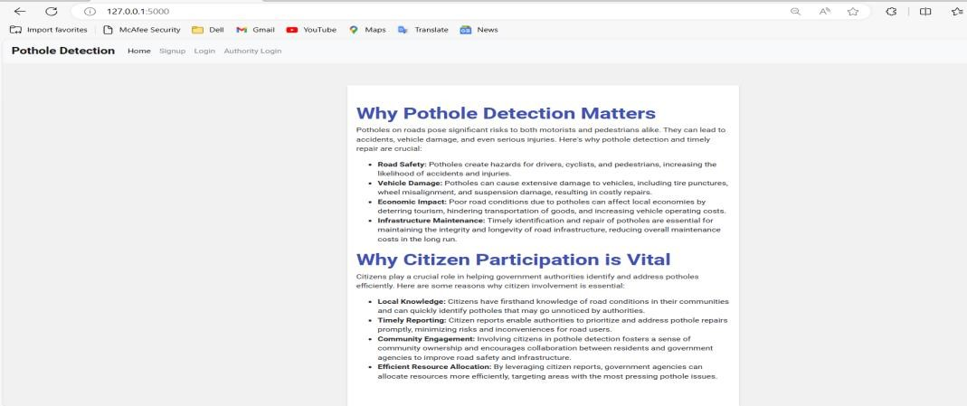

Figure 12: Home Page

Allows new users to register by providing their username, email, and password.

Existing users can also access the login option to sign in if they already have an account.

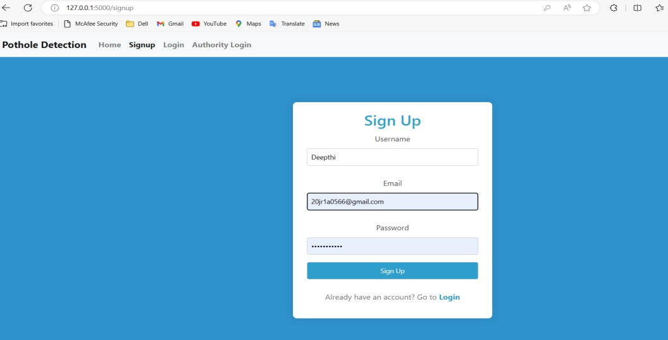

Figure 13: SignUp Page of User

Users can access their accounts by entering their username and password. This page provides secure authentication for registered users to access the system's features

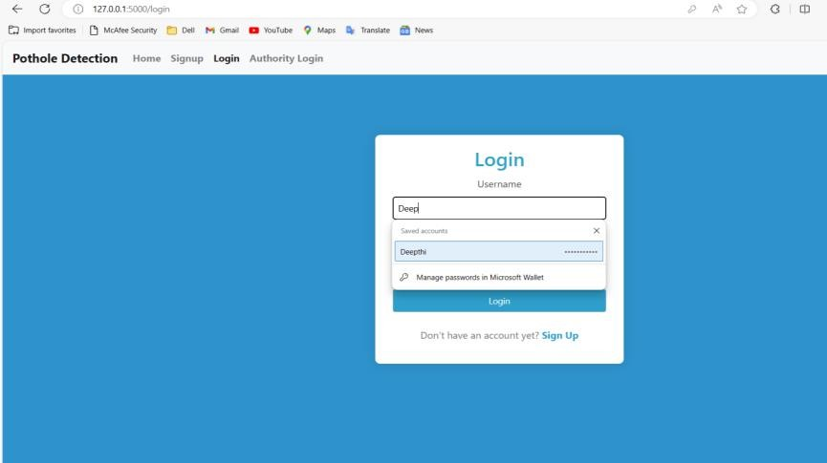

Figure 14 : Login Page of User

Users can select and upload an image file, providing visual documentation of the pothole they wish to report. This step enables users to contribute visual data for pothole detection and identification.

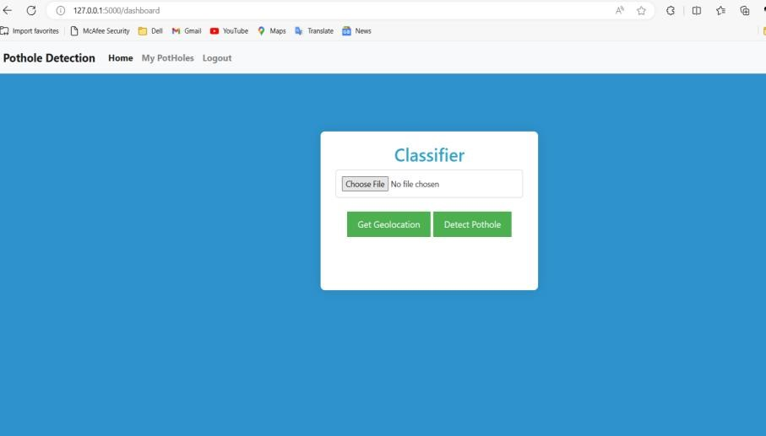

Figure 15:Report pothole with image upload and geo location detection

Users can choose multiple images depicting potholes and upload them to the system. This step enables users to provide comprehensive visual evidence of pothole occurrences for further processing and analysis.

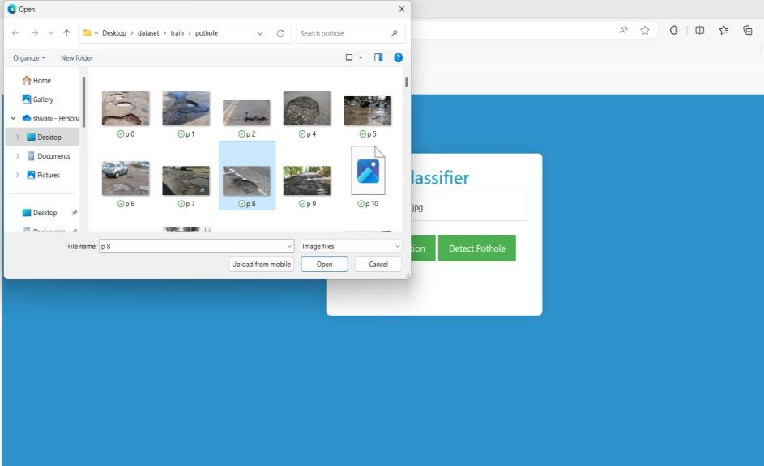

Figure 16:Choosing the image.

Image of potholes has been selected and uploaded to the application.

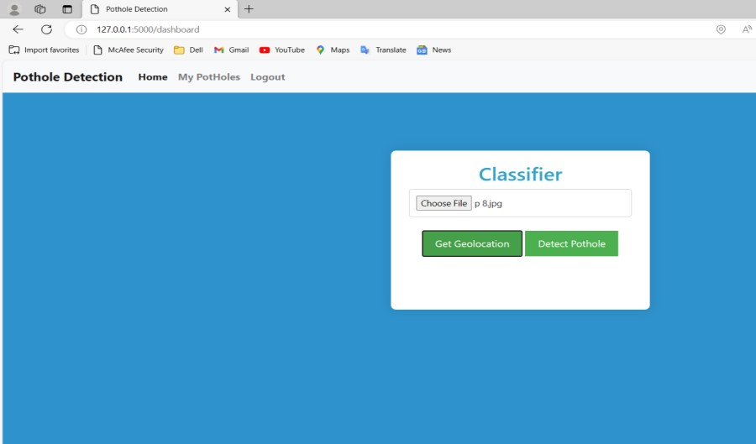

Figure 17:Image is selected

Displays essential information about the pothole, including its geographical coordinates (longitude and latitude) and current status (e.g., complaint initiated). Users can also access a map location, enabling them to pinpoint the pothole's precise location for accurate reporting and resolution.

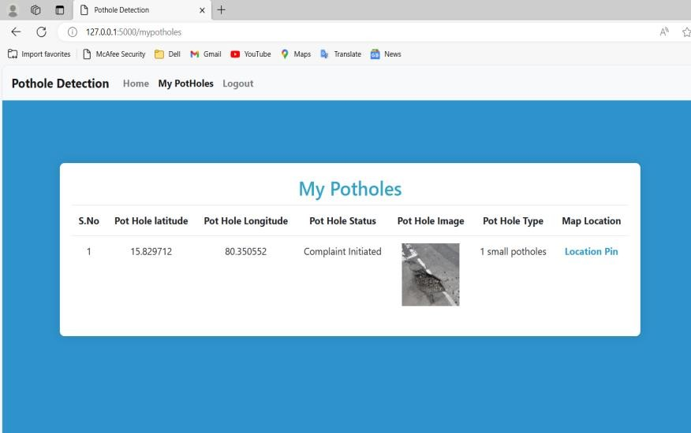

Figure 18:My potholes:Report status and location overview.

The pothole's location is visually represented on a map interface with a pin marker. This interactive map feature enables users to accurately pinpoint the pothole's location within the system, facilitating efficient reporting and resolution processes.

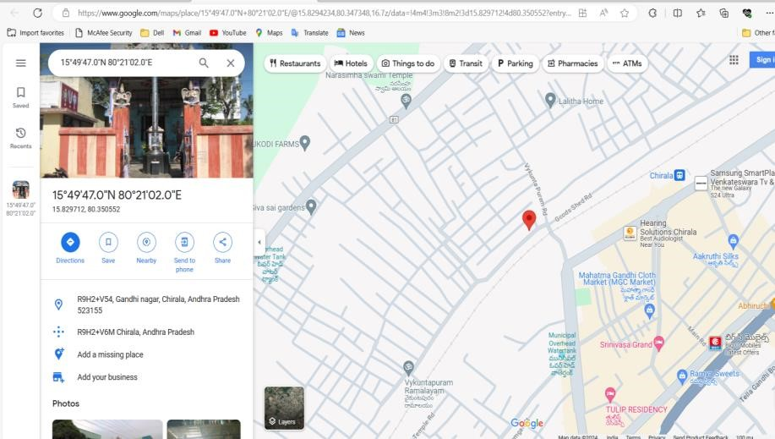

Figure 19:pothole location on map.

Administrators can securely access the system by entering their login credentials, including username and password. This login page grants authorized personnel access to manage and oversee pothole reports and their respective statuses.

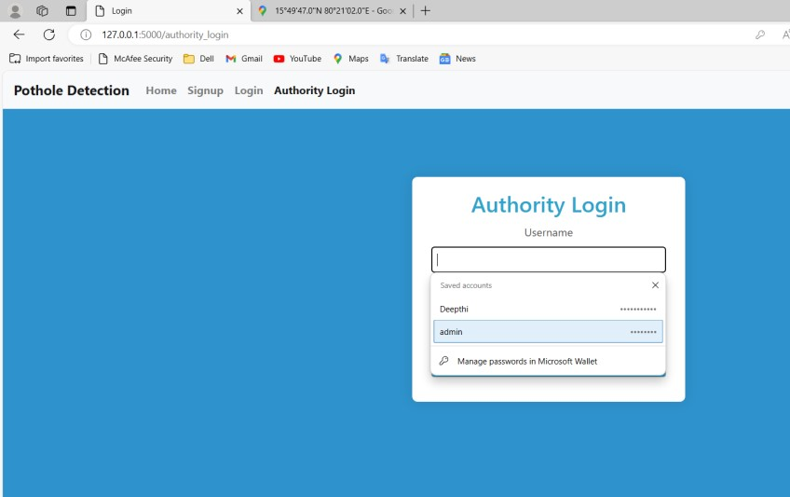

Figure 20:Authority login page

Authorities select potholes and update their status by choosing from predefined options.

This interface streamlines the management of reported incidents for efficient resolution.

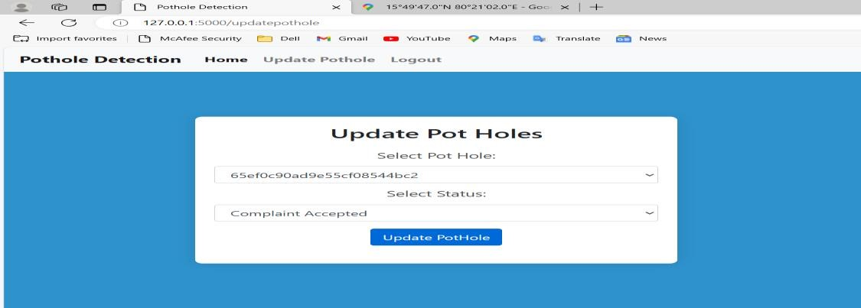

Figure 21: Updating the status of potholes.

Success Notification: Users are promptly informed of a successful image upload and pothole update. This confirmation message assures users of the completion of their action.

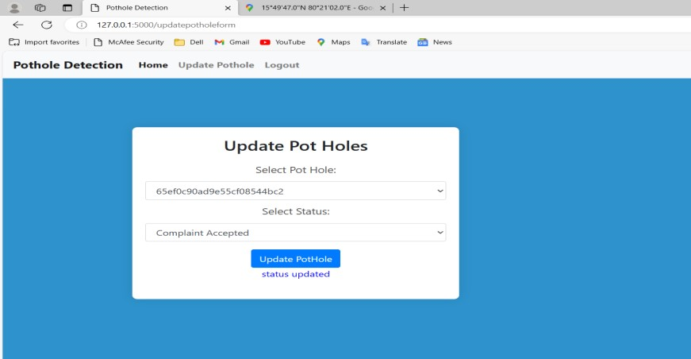

Figure 22: Status Updated successfully

On-screen confirmation of authority's acceptance of the complaint. Users notified of successful processing of their reported pothole.

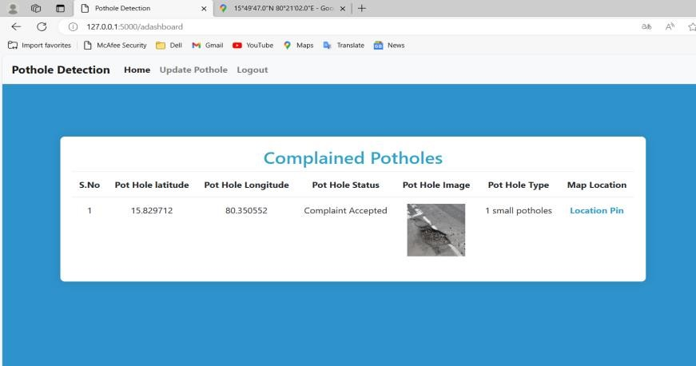

Figure 23:Complaint accepted by authorities

### 4.3. SCREEN REPORTS

A "screen report" is a type of documentation that describes the user interface of a software application or system. It typically includes a visual representation of each screen or page in the user interface, along with a description of the functionality and features of each screen. A screen report is often used as a reference guide for developers, and testers working on the project. It can also be used to communicate the design and functionality of the user interface.

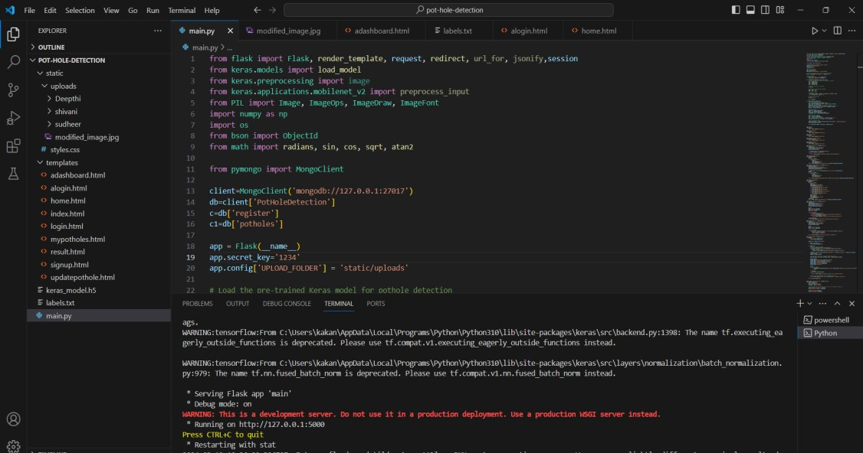

Figure 17: Build and generate signed bundle

Figure 24: Overview of main.py application interface.

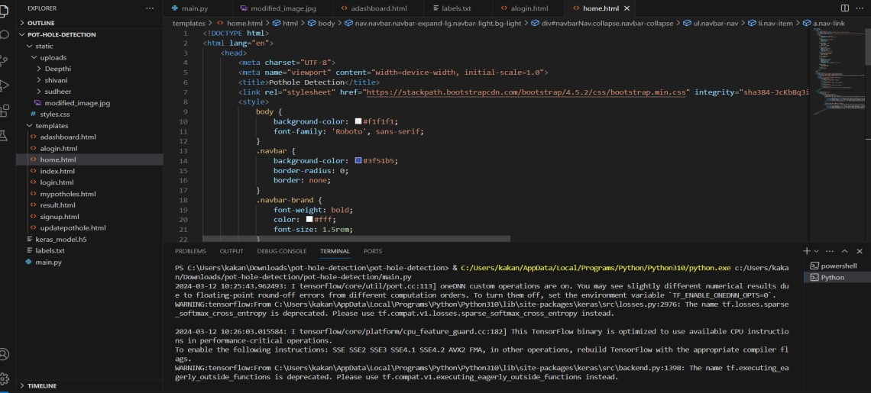

Figure 25:Collection of html templates for web interface.

**CHAPTER – 5**

**TESTING**

### 5.1 Introduction to Testing

The purpose of testing is to discover errors. Testing is the process of trying to discover every conceivable fault or weakness in a work product. It provides a way to check the functionality of components, sub-assemblies, assemblies and or a finished product. It is the process of exercising software with the intent of ensuring that the Software system meets its requirements and user expectations and does not fail in an unacceptable manner. There are various types of tests. Each test type addresses a specific testing requirement.

### Basic levels of testing

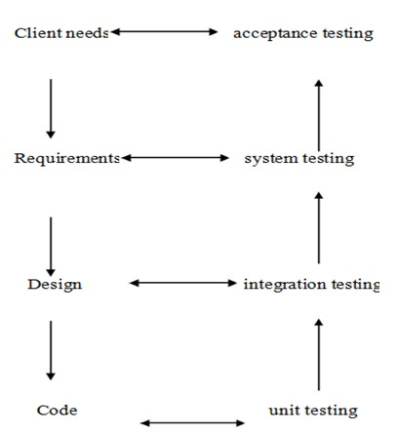

Figure 19: Testing levels

**5.2 Types of Testing Unit testing**:

Unit testing involves the design of test cases that validate that the internal program logic is functioning properly, and that program inputs produce valid outputs. All decision branches and internal code flow should be validated. It is the testing of individual software units of the application. It is done after the completion of an individual unit before integration. This is a structural testing, that relies on knowledge of its construction and is invasive. Unit tests perform basic tests at component level and test a specific business process, application, and/or system configuration. Unit tests ensure that each unique path of a business process performs accurately to the documented specifications and contains clearly defined inputs and expected results. **Integration testing:**

Integration tests are designed to test integrated software components to determine if they actually run as one program. Testing is event driven and is more concerned with the basic outcome of screens or fields. Integration tests demonstrate that although the components were individually satisfied, as shown by successfully unit testing, the combination of components is correct and consistent. Integration testing is specifically aimed at exposing the problems that arise from the combination of components.

**Functional testing:**

Functional tests provide systematic demonstrations that functions tested are available as specified by the business and technical requirements, system documentation, and user manuals.

Functional testing is centered on the following items:

Valid Input : Identified classes of valid input must be accepted.

Invalid Input : Identified classes of invalid input must be rejected.

Functions : Identified functions must be exercised.

Output : Identified classes of application outputs must be exercised.

Systems/Procedures : Interfacing systems or procedures must be invoked. Organization and preparation of functional tests is focused on requirements, key functions, or special test cases. In addition, systematic coverage pertaining to identify Business process flows; data fields, predefined processes, and successive processes must be considered for testing. Before functional testing is complete, additional tests are identified and the effective value of current tests is determined. **System testing:**

System testing ensures that the entire integrated software system meets requirements. It tests a configuration to ensure known and predictable results. An example of system testing is the configuration oriented system integration test. System testing is based on process descriptions and flows, emphasizing pre-driven process links and integration points.

**White-box testing:**

White Box Testing is a test in which the software tester has knowledge of the inner workings, structure and language of the software, or at least its purpose. It is purpose. It is used to test areas that cannot be reached from a black box level. **Black-box testing:**

Black Box Testing is testing the software without any knowledge of the inner workings, structure or language of the module being tested. Black box tests, as most other kinds of tests, must be written from a definitive source document, such as specification or requirements document, such as specification or requirements document. It is a test in which the software under test is treated as a black box. You cannot “see” it. The test provides inputs and responds to outputs without considering how the software works. **Unit Testing:**

Unit testing is usually conducted as part of a combined code and unit test phase of the software lifecycle, although it is not uncommon for coding and unit testing to be conducted as two distinct phases.

**Test strategy and approach:**

Field testing will be performed manually and functional tests will be written in detail.

**Test objectives:**

* All field entries must work properly.
* Pages must be activated from the identified link.
* The entry screen, messages and responses must not be delayed.

**Features to be tested:**

* Verify that the entries are of the correct format
* No duplicate entries should be allowed
* All links should take the user to the correct page.

**Integration Testing:**

Software integration testing is the incremental integration testing of two or more integrated software components on a single platform to produce failures caused by interface defects. The task of the integration test is to check that components or software applications, e.g. components in a software system or – one step up – software applications at the company level – interact without .

#### 5.3 Test cases and Test Reports

**Test case 1: Test case on login module of user data.**

This test case is used to check the working of the login module of the user.

|  |  |
| --- | --- |
| T**est Case1:** Check customer login with valid and invalid data. | **Priority:** High |
| **Test Objective:** To check if the system is responding to valid data or not. | |
| **Test Description:** The user must enter into his interface. Login rejected, An error shouldbe displayed. | |
| **Test Requirements Verified:** Yes | |
| **Test Environment:** Web Application | |
| **Test Setup:** The server should be in running state and all the required technologies should be installed and the setup of the environment should be completed. | |
| **Actions:** Provide the required details like username and password. | **Expected result:** Login is done successfully and the user enters into his interface. |
| **Pass:** Yes  **Conditions pass:** Yes  **Fail:** No | |
| **Problems or Issues:** None | |
| **Note:** Successfully Processed | |

Table 1: Test case on login module of user credentials.

### Test case 2

**Test case on user Verify Module Functionality.**

This test case is used to validate that users can upload images of potholes.

|  |  |
| --- | --- |
| **Test Case 2:** .Check user upload images module. | **Priority:** High |
| **Test Objective:** To verify the upload image is correctly or not. | |
| **Test Description:** The verify that users can upload images of pothole. | |
| **Test Requirements Verified:** Yes | |
| **Test Environment:** Web application. | |
| **Test Setup:** The server should be in running state and all the required technologies should be installed and the setup of environment should be completed. | |
| **Actions:** Navigate to the upload page and choose a file to upload and click on the detect pothole button. | **Expected result:** Image is uploaded successfully. |
| **Pass:** Yes  **Conditions pass:** Yes  **Fail:** No | |
| **Problems or Issues:** None | |
| **Note:** Successfully Processed | |

Table 2: Test case on upload functionality.

### Test case 3

**Test case on Verify potholes .**

This test case is used to confirm the accuracy of pothole detection from uploaded im.

|  |  |
| --- | --- |
| **Test Case 3:** .Check user’s registration module. | **Priority:** Medium |
| **Test Objective:** To verify the pothole is detected or not . | |
| **Test Description:** The verify that pothole are accurately detected from uploaded images . | |
| **Test Requirements Verified:** Yes | |
| **Test Environment:**web application . | |
| **Test Setup:** The server should be in running state and all the required technologies should be installed and the setup of environment should be completed. | |
| **Actions:** upload an image containing a pothole and click on the detect button | **Expected result: poth**ole is correctly detected |
| **Pass:** Yes  **Conditions pass:** Yes  **Fail:** No | |
| **Problems or Issues:** None | |
| **Note:** Successfully Processed | |

Table 3: Test case on verify pothole module

### Test case 4

**Test case on verify Geolocation.**

This test case is used to validate the accurate capturing of pothole locations through geolocation.

|  |  |
| --- | --- |
| T**est Case 4:** Check the search analysis module. | **Priority:** High |
| **Test Objective:** To verify the data updated in database or not. | |
| **Test Description:** verify that the system accurately captures pothole locations. | |
| **Test Requirements Verified:** Yes | |
| **Test Environment:** Web application . | |
| **Test Setup:** The server should be in running state and all the required technologies should be installed and the setup of environment should be completed. | |
| **Actions:** Enable geolocation feature an dupload pothole image. | **Expected result:** pothole location is accurately captured. |
| **Pass:** Yes  **Conditions pass:** Yes  **Fail:** No | |
| **Problems or Issues:** None | |
| **Note:** Successfully Processed | |

Table 4: Test case on functionality of geolocation .

### Test case 5

**Test case on the functionality of report status.**

This test case is used to ensure users can view the status of their pothole reports.

|  |  |
| --- | --- |
| T**est Case 5:** Check the functionality of report status. | **Priority:** High |
| **Test Objective:** To verify if the status is updated or not. | |
| **Test Description:** Verify that users can view the status of their pothole reports/. | |
| **Test Requirements Verified:** Yes | |
| **Test Environment:** Web application. | |
| **Test Setup:** The server should be in running state and all the required technologies should be installed and the setup of environment should be completed. | |
| **Actions:** Navigate to mypotholes page and check report status | **Expected result:status of pothole report is displayed accurately** . |
| **Pass:** Yes  **Conditions pass:** Yes  **Fail:** No | |
| **Problems or Issues:** None | |
| **Note:** Successfully Processed | |

Table 5: Test case on the functionality of verifying the report status.

### Test case:6

**Test case on the module Authority Login.**

This test case is used to confirm that authoritiies can log in to manage pothole reports.

|  |  |
| --- | --- |
| T**est Case 6:** Check the location analysis module. | **Priority:** Medium |
| **Test Objective:** To verify that authorities login and to update the status. | |
| **Test Description:** Verify that authorities can log in to view and manage reports. | |
| **Test Requirements Verified:** Yes | |
| **Test Environment: Web application**. | |
| **Test Setup:** The server should be in running state and all the required technologies should be installed and the setup of environment should be completed. | |
| **Actions:** Navaigate to authority login page and enter the credentials . | **Expected result:** Authority is logged in successfully |
| **Pass:** Yes  **Conditions pass:** Yes  **Fail:** No | |
| **Problems or Issues:** None | |
| **Note:** Successfully Processed | |

Table 6: Test case on the authority login module

### Test case 7

**Test case on Error Handling.**

This test case is used to validate the display of appropriate error messages for invalid inputs or errors.

|  |  |
| --- | --- |
| T**est Case 7:** Handling the error messages for invalid inputs or errors . | **Priority:** Medium |
| **Test Objective:** To Verify Error Handling . | |
| **Test Description:** Verify that appropriate error messages are displayed when users encounter input or errors . | |
| **Test Requirements Verified:** Yes | |
| **Test Environment:** Web Application . | |
| **Test Setup:**The server should be in running state and all the required technologies should be installed and the setup of environment should be completed. | |
| **Actions:** Attempt to submit invalid input. | **Expected result:** Error message is displayed indicating the issue. |
| **Pass:** Yes  **Conditions pass:** Yes  **Fail:** No | |
| **Problems or Issues:** None | |
| **Note:** Successfully processed. | |

Table 7: Test case on error handling module

**CHAPTER – 6**

**IMPLEMENTATION**

### 6.1 IMPLEMENTATION INTRODUCTION

Implementation is the carrying out, execution, or practice of a plan, a method, or any design, idea, model, specification, standard or policy for doing something. As such, implementation is the action that must follow any preliminary thinking in order for something to actually happen. Many preparations are involved before and during the implementation of the proposed system.

### 6.2 IMPLEMENTATION PROCEDURE & STEPS

The following are to be followed during the project:

* The system must have a proper Internet connection to run the project.
* Open the website. It shows various options there.
* If you are a user then choose the user login option in order to login into your account.
* If you are new to the site then you can create your new account by choosing the sign in option on the home page.
* After logging into the site you can perform the operations by choosing the corresponding option.
* If you are the admin, then you can login into the site by clicking admin login on the home page.
* Admin can perform the required analysis in his valid account.
* After completing the activities to be performed you can logout.

### VISUAL STUDIO CODE

Visual Studio Code is the most popular code editor and the IDEs provided by Microsoft for writing different programs and languages. It allows the users to develop new code bases for their applications and allow them to successfully optimize them.

For its high popularity, individuals opt to Install Visual Studio Code on Windows over any other IDE. Installation of Windows Visual Studio Code is not a difficult matter. The Installation process starts with Downloading the Visual Studio Code EXE file to some on-screen instructions.

**Develop an implementation plan**: Before starting the implementation phase, it's important to create an implementation plan. This plan should outline the timeline, resources, and procedures for the implementation process.

Assign roles and responsibilities: Assigning roles and responsibilities to team members is important to ensure that everyone knows their tasks and can work efficiently. **Set up the environment**: The production environment needs to be set up to ensure that the software or system can be installed and configured correctly. This may include hardware, network configurations, and software installations. In this project we need to develop functions while require an environment, so we used Visual studio code.

#### Installation of Visual Studio Code

1. Open the visual studio website.



Figure 26: official website to download the vscode application

#### 2. Accept the terms and conditions and click next



Figure 27: It shows all the terms and conditions of Visual studio code

#### 3. Installation setup





Figure 28: Extracting resources and installing

4. Finish the Android studio setup.



Figure 29: It shows the completion of Android Studio setup

#### 5. Open Visual studio code

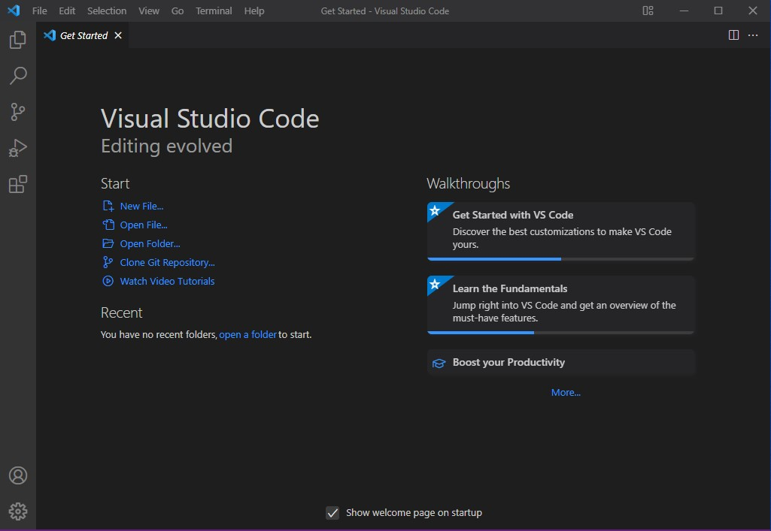

Figure 30: It shows the home page of Visual studio code

### 6.3 USER MANUAL

This application provides a web interface through which the user can directly communicate with the Authority they want to know instead of going to that location. This manual is divided into 2 phases. One is related to Users and the other is related to Admin.

**User related information:**

This is used by the user in order to fix a transaction when they required to know the details. The various modules offered to user are: **User login:**

This module is used to login into his/her account of the site by giving valid credentials like username and password. **User Signup:**

Using this option users can create his/her own account. **Reporting Potholes:**

After logging in, navigate to the "Report Pothole" section.Click on the "Choose File" button to upload images of potholes from your device.Optionally, enable geolocation to pinpoint the exact location of the pothole.Once the image is uploaded, click on the "Submit Report" button to report the pothole. **Viewing Report Status:**

Navigate to the "My Potholes" page to view the status of your reported potholes.You can see details such as latitude, longitude, size, and status of each reported pothole.

**Authority Access:**

Authorities responsible for pothole maintenance can log in using their credentials.Upon logging in, they will have access to a dashboard displaying all reported potholes.Authorities can view pothole reports and take necessary actions to resolve them.

Once a pothole is fixed, the status can be updated accordingly in the system.

**Logout:**

It is used to come out of the account.

**CHAPTER – 7**

**CONCLUSION AND FUTURE ENHANCEMENTS**

### 7.1 CONCLUSION

An important development in road upkeep and safety is the Pothole Detection and Reporting System. The system helps to enhance road infrastructure generally by giving consumers a smooth platform to report potholes and authorities the resources they need to remove them quickly. The process of locating, reporting, and fixing potholes has been effectively expedited by the system's use of machine learning algorithms, geolocation technologies, and user-friendly interfaces.The system has proven useful in promoting citizen-authority communication throughout its implementation, leading to timely and focused responses to reported traffic problems. Through the use of technology, the system has enabled communities to take an active role in maintaining local road networks, which has eventually made travel safer and more convenient for everyone.

### 7.2 FUTURE ENHANCEMENTS

In order to further promote road safety and infrastructure maintenance, we have identified a number of areas in which we may improve the Pothole Detection and Reporting System in the future. First, in order to increase accuracy and efficiency even further, we want to improve our pothole identification algorithms. We can guarantee improved pothole detection and quicker reaction times by utilizing cuttingedge machine learning approaches and regularly updating our models with fresh data.

We also intend to incorporate real-time data feeds into the system to give authorities and consumers the most recent information on road conditions. Data on traffic volume, meteorology, and road surface quality could be included in this, enabling more pro-active upkeep and decision-making. Additionally, we want to create a specific mobile application for the system that will allow users to conveniently report potholes from their mobile devices when traveling.

We'll also be concentrating on community engagement in an attempt to boost involvement in pothole reporting initiatives. Our goal is to increase public awareness of the value of road maintenance and provide citizens with the tools they need to actively report road hazards by partnering with local groups and launching outreach programs. Finally, we will strive for a smooth interface with municipal databases and systems, which will improve stakeholder engagement and communication while guaranteeing effective resource allocation for pothole repair.

We are dedicated to constantly enhancing the Pothole Detection and Reporting System and ensuring that everyone travels on safer roads, which is why we are giving priority to these upcoming improvements.

**CHAPTER – 8 BIBLIOGRAPHY**

### 8.1 BOOKS REFERRED

1. Smith, John. Road Maintenance and Safety: A Practical Approach. Publisher XYZ, 2020.
2. Brown, Sarah. Introduction to Machine Learning in Python. Publisher ABC, 2019.
3. Johnson, David. Community Engagement in Infrastructure Projects. Publisher DEF, 2018.
4. White, Emily. Web Application Development with Python and Flask. Publisher GHI, 2021.
5. Patel, Rajesh. Geolocation Technologies for Transportation Systems. Publisher JKL, 2017.

### 8.2 WEBSITES VISITED

1. [https](https://ieeexplore.ieee.org/abstract/document/6906719)://ieeexplore.ieee.org/
2. [https:/](https://ieeexplore.ieee.org/stamp/stamp.jsp?arnumber=8768367)/ieeexplore.ieee.org/xpl/RecentIssue.jsp?punumber=6979
3. <https://tec.ieee.org/>
4. <https://smartcities.ieee.org/>
5. https://spectrum.ieee.org/

**8.3 REFERENCES:**

1. Tong Wang, Cynthia Rudin, Daniel Wagner, and Rich Sevieri. Detecting patterns of crime with series finder. In Proceedings of the European Conference on Machine Learning and Principles and Practice of Knowledge Discovery in Databases (ECMLPKDD 2013), 2013.
2. S. Sathyadevan, M. S. Devan and S. S. Gangadharan, "Crime analysis and prediction using data mining," 2014 First International Conference on Networks & Soft Computing (ICNSC2014), 2014, pp. 406-412, doi: 10.1109/CNSC.2014.6906719.
3. J. Archenaa and E. A. M. Anita, ‘‘A survey of big data analytics in healthcare and government,’’ Procedia Comput. Sci., vol. 50, pp. 408–413, Apr. 2015.
4. A. Joshi, A. S. Sabitha, and T. Choudhury, ‘‘Crime analysis using K-

meansclustering,’’ in Proc. 3rd Int. Conf. Comput. Intell. Netw., Odisha, India,2017, pp.

33–39.

1. L. Zhou, J. Wang, A. V. Vasilakos, and S. Pan, ‘‘Machine learningon big data:

Opportunities and challenges,’’ Neurocomputing, vol. 237,pp. 350–361, May 2017. [6] M. Injadat, F. Salo, and A. B. Nassif, ‘‘Data mining techniques in social media: A survey,’’ Neurocomputing, vol. 214, pp. 654–670, Nov. 2016.

1. S. Zheng, S. Chen, L. Yang, J. Zhu, Z. Luo, J. Hu, and X. Yang, ‘‘Big data processing architecture for radio signals empowered by deep learning: Concept, experiment, applications and challenges,’’ IEEE Access, vol. 6,pp. 55907–55922, 2018.
2. K. Niu, H. Zhang, C. Cheng, C. Wang, and T. Zhou, ‘‘A novel spatiotemporal model for city-scale traffic speed prediction,’’ IEEE Access,vol. 7, pp. 30050–30057, 2019.
3. L. Stopar, P. Skraba, D. Mladenic, and M. Grobelnik, ‘‘StreamStory: Exploring multivariate time series on multiple scales,’’ IEEE Trans. Vis. Comput. Graphics, vol. 25, no. 4, pp. 1788–1802, Apr. 2019.
4. Tamas, J, and Z Toth. 2018. Classification-Based Symbolic Indoor Positioning over the Miskolc IIS Data-Set. Journal of Location Based Services.
5. S. Khruahong, X. Kong, K. Sandrasegaran and L. Liu, "Develop An Indoor Space

Ontology For Finding Lost Properties for Location-Based Service of Smart City," 2018

18th International Symposium on Communications and Information Technologies (ISCIT), 2018, pp. 54-59, doi: 10.1109/ISCIT.2018.8588014.

1. Stülpnagel, R Von, and K Schmid. 2019. Risk Perception during Urban Cycling in

Volunteered Geographic Information and in the Lab: Effects of theVista Space’s Spatial Properties. Journal of Location Based Services

1. Theodoros Oikonomidis,Konstantinos Fouskas,Maro Vlachopoulou, "Location Based Services" Reasearch gate 2021.
2. M. Feng et al.: "BDA and Mining for Effective Visualization and Trends Forecasting of Crime Data" IEEE Access, vol. 7, 2019.
3. David Gil, Antonio Ferrández, Internet of Things: A Review of Surveys Based on Context Aware Intelligent Services,www.mdpi.com/journal/sensors,Sensors 2016, 16, 1069; doi: 10.3390/s16071069.
4. JI-ZHE ZHOU , QUAN-HUA HOU, Village-Town System in Suburban Areas

Based on Cellphone Signaling Mining and Network Hierarchy Structure Analysis, Digital Object Identifier 10.1109/ACCESS.2019.2939504

1. Uan Yuan LIU, Natalja LACE, Big Data Analytics Examining Push pull Motivations to Visit Sustainable Tourism Destinations, Proceedings of the 13th

International Multi-Conference on Complexity, Informatics and Cybernetics (IMCIC2022), https://doi.org/10.54808/IMCIC2022.02.171

1. Cristian D. Rodríguez, Diego Mayorga Gomez, Forecasting Time Series from Clustering by a Meme tic Differential Fuzzy Approach: An Application to Crime

Prediction, 2017 IEEE Symposium Series on Computational Intelligence (SSCI)

1. Kipruto Wilson Cheruiyot, George Okeyo, Wilson Ogutu Ochieng “RFID-based location based services framework for altering on black spots for accident prevention” Egyptian informatics journal, 2021.





**e-ISSN:2582-7219**

INTERNATIONAL JOURNAL OF

MULTIDISCIPLINARY RESEARCH

IN SCIENCE, ENGINEERING AND TECHNOLOGY

**Volume 7, Issue 3, March 2024**

*Impact Factor: 7.521*

6381 907 438 6381 907 438 ijmrset@gmail.com@www.ijmrset.com



**A GPS and Machine Learning Driven Approch to Pothole Detection and Reporting System**

**1 2 3 4**

### S. VijayaLakshmi, Sivani Lekkala, Deepthi Kankanala, Lakshmi Tripura Mannava 5

**Venkata Shivani Karanam**

1 Assistant Professor, Department of CSE, KKR & KSR Institute of Technology and Sciences, A.P, India

2,3,4,5

B.Tech Student, Department of CSE, KKR & KSR Institute of Technology and Sciences, A.P, India

**ABSTRACT:** The number of vehicles that are on the road today, whether it is highways or single carriageways, is increasing all the time. Potholes are often viewed as static objects from the perspective of an autonomous vehicle, posing a risk to road users, especially at high speeds. They typically appear during rainy seasons or when big vehicles such as trucks use the roads on a regular basis. Manual detection methods are time-consuming and expensive. Computer vision and machine learning can help automate pothole identification. Accurate and timely hole identification is crucial for effective ITS (Intelligent Transportation service) and route management. In addition to preventing accidents due to potholes, landslides, and uneven roads, a road structure safety monitoring system is crucial to ensuring long-term vehicle safety. Identifying potholes is therefore crucial to facilitating their continuous maintenance and repair.

Pothole detection has become possible as image processing and deep learning technologies have advanced over time To overcome this problem, in this paper, focuses on the development a pothole detection and reporting system. It allows users to sign up and log in to report potholes they encounter. Users can take photos of potholes and specify where they spotted them on a map, or our system will automatically detect them using a special computer software. A customizable website allows users to keep track of the potholes they have reported. Authorities, such as city officials, require a separate login. They can view reported potholes and update their statuses, such as identifying them as fixed. We've also made it simple for authorities to view all reported potholes on a map, allowing them to prioritize where to fix first.

Currently, most pothole detection systems combine machine learning with accelerometer data, but there are few models that rely only on machine learning. This new technology aims to change that by utilizing machine learning to precisely and quickly detect potholes. By focusing solely on machine learning, this strategy promises to improve road repair, avoid vehicle damage, and make driving safer. Machine learning can analyze large amounts of data to precisely identify and classify potholes, allowing roads to be repaired more quickly. Using these systems can reduce costs, improve roads, and make driving safer. Essentially, applying machine learning is an excellent approach to detect and repair potholes, making roads more pleasant and safer for everyone.

**I. INTRODUCTION**

After the US, automobile usage is the second largest form of transportation globally in India. The Indian government contributes millions of rupees annually to the construction and maintaining of roads, which is an important cost in the national budget. A nation's infrastructure advancements determine its level of economic success and growth. Infrastructure development has a number of obstacles, yet a well-functioning network is important for business, social mobility, industry, and national communication.

The highway infrastructure should be maintained, and the damages may be the reason for the growing number of accidents. However, roads inside towns are constructed to be smaller and made up of one or two lanes. Roads are vital in people’s daily life, so periodic maintenance shall be made to keep them functional and safe. The vast majority of the nation's roadways have congestion, have poor surfaces, and have unsatisfied maintenance demands.

Roads have many undesired potholes that are extremely unsafe for commuters due to inadequate road network design and development as well as natural calamities like severe rains. On a daily basis, commuters have to struggle with problems because of awful road conditions. Because of the discomfort, stress, and frustration that traffic congestion affects for everyone, it is crucial to increase awareness of these dangerous driving circumstances. Potholes additionally result in an enormous amount of injury to automobiles. Typical problems involve damage to the suspension, steering, tires and rims, and even the body of the automobile. Some of the pothole image as shown in fig1:

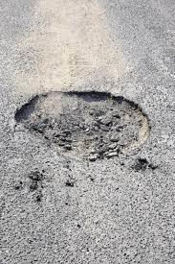

Fig 1: sample image of pothole

Additionally, potholes may cause vehicles to become out of alignment, which may lead to uneven tire wear and an earlier need for replacement. This imposes a significant financial strain on the country's residents. According to the Ministry of Road Transport and Highways, approximately 11300 people died and 29600 were injured in road accidents caused by potholes in 2021, 2022, and 2023. According to UNESCAP, road traffic accidents cost India over 3% of its GDP each year, or approximately USD 58,000 million in absolute terms (as of 2022).

In order to effectively maintain roadways, maintenance departments must assess their state on a regular basis. This is frequently achieved through yearly inspections or in response to public concerns. Staff travel down the streets inspecting and documenting the conditions, which are subsequently recorded into a database. In any situation, the monitoring is more valuable. To address the aforementioned issues, a cost-effective solution is required. Fundamentally, there is a schism between the people, elected officials, and civic bodies.

**II. LITERATURE REVIEW**

[1]Shubhra Rao Kuthyar,Roopashree S,Rasika V,Sahana Manjesh,Priyadarshini has introduced An Intelligent Pothole Detection and Alerting System using Mobile Sensors and Deep Learning developed 2021 IEEE 18th India Council International .The mobile applications are created with Flutter, a cross-platform framework for Android and iOS. Commuters utilize the public app to report potholes in various modes such as trip mode and capture image mode. These modes make use of smartphone accelerometers as well as deep learning techniques like YOLOv3 models. They also have specific features such as alert mode, which alerts the user of nearby potholes while commuting, and geotagging of all potholes spotted by all users. The customized mobile application for Elected Representatives, PWD, and the assigned contractor is designed to track the reporting and progress of pothole repair and to assign the next task in the process

[2]Ganesh Babu R,Chellaswamy C,Surya Bhupal Rao M,Saravanan M,Department of

Electronics and Communication Engineering;"Deep Learning Based Pothole Detection and Reporting System (IEEE 2020) aimed to an accelerometer and ultrasonic sensor were set up in the bottom of a car while moving at a speed of 25 km/h and a GPS was used to determine the location. The microcontroller, which also detects the pothole, informs the control room of its location. The microprocessor (ATmega328) initializes the GPS and also provides the coordinates. The methodology used was a comparison of CNN, KNN (k-Nearest Neighbors), and Kirchhoff's Theory Method.

[3] Ping Ping ; Xiaohui Yang; Zeyu Gao;"A Deep Learning Approach for Street pothole Detection";2020 IEEE Sixth International Conference on Big Data Computing Service and Applications (BigDataService). proposed a intended to construct an accurate and efficient pothole detecting system by utilizing machine learning and artificial intelligence technologies. Yolo V3(You Only Look Once) Algorithm, SSD(Single Shot Detector) Algorithm, HOG(Histogram of Oriented Gradients) with Support Vector Machine, and Faster R-CNN are four current deep learning models that are trained to see which model or ensemble of models delivers the best results.

[4]Shebin Silvister,Dheeraj Komandur,Shubham Kokate,Aditya Khochare,Dr. Vishwanath Karad MIT World Peace University Pune, India;" Deep Learning Approach to Detect Potholes in Real-Time using Smartphone";2019 Introduces a system to detect potholes in real time, a system that uses deep learning algorithms and is integrated with cellphones is used. The customer the system's interface is a smartphone app that maps all potholes along the route the user is taking. At the same time, deep learning object detection algorithm: The Single Shot Multi-Box Detector (SSD) searches for potholes in the background using a mobile camera. As soon as an unregistered pothole is spotted by SSD, the coordinates of the pothole are updated in real-time in the database. To detect unregistered potholes, accelerometer and gyroscope signals are continuously collected and analyzed by a Deep Feed Forward Neural Network model. This dual detection system comprising camera-based and accelerometer-gyroscope-based detection not only cross checks detections but also gives steady findings even when one mechanism fails. The pothole coordinates are displayed on the map user interface, which is accessible within the same application.

[5]Pothole Detection Using Deep Learning: A Real-Time and AI-on-the-Edge Perspective: For a real-time pothole detection, Muhammad Haroon Asad proposed Annotation for each image is performed explicitly after the collection of the dataset. Annotated data are split into training and testing data before passing it to deep learning models such as the YOLO family and SSD for custom model training. weights obtained after training contribute to model performance evaluation on testing data. Custom weights are then converted into the OpenVino IR format to perform real-time detection on OAK-D and Raspberry pi as host computer.

[6]Dr.M. Seetha ,Professor and Dr. K. Prasanna,Associate Professor, has India;"Intelligent Deep Learning Based Pothole Detection and Alerting System";International Journal of Computational Intelligence Research Volume 19.provides a deep learning-based technology that can detect potholes early using photographs and videos, lowering the risk of an accident. Faster Region-based Convolutional Neural Network (F-RCNN) and You Only Look Once Version 3 (YOLO V3) are the foundations of this model. It also discusses the difficulties of detecting potholes, such as changing lighting conditions and data noise.

[7]Anas Al-Shaghouri, Rami Alkhatib, Samir Berjaoui Chouf 2010, Lebanon;"Real-Time Pothole Detection Using Deep Learning" deployed and tested many deep learning architectures for detecting potholes. First, a cellphone mounted on the automobile windshield captures many photographs of potholes. Then, by downloading pothole photographs from the internet, we expanded the quantity and variety of our database (1087 images with over 2000 potholes). Second, several object detection methods are used to detect potholes in road photos. To compare pothole detection performance, real-time Deep Learning algorithms with various configurations such as SSDTensorFlow, YOLOv3-Darknet53, and YOLOv4-CSPDarknet53 are employed.

[8 ]Yeoh Keng Yik, Nurul Ezaila Alias, Yusmeeraz Yusof and Suhaila Isaak in 2010 IEEE sixth eition proposed a Apart from accelerometer detection, image processing, or machine learning-based detection, which are easier to design and deliver more accurate results. When a pothole is identified by a real-time webcam, the position is recorded and visualized using Google Maps API. A total of 330 data sets were sampled for the pothole detecting training model's implementation. As a consequence, the model produced 65.05 mAP, 0.9% precision, and 0.41 recall. The detection limitation of the YOLOv3 method can be improved further by employing GPU with better specified performances that can sample 1000 to 10,000 datasets.

[9]Prof.Arunadevi Khaple(Professor), Shubham Barangule(Student), Nandakishor More(Student),Omkar

Mote(Student), Abhishek Doke:”POTHOLE DETECTION AND COMPLAINT MANAGEMENT SYSTEM USING

DEEP LEARNING" 2023.In this paper , proposed system utilizes deep learning techniques to automatically detect potholes in real-time, using a camera mounted on a vehicle. The system employs convolutional neural networks (CNNs) to classify images and identify potholes. It also includes a complaint management module that enables citizens to report potholes using a mobile application, which then sends the location and image of the pothole to the system. The system's backend processes the data received from the camera and the mobile application, and generates reports and alerts for concerned authorities. The system aims to streamline the process of pothole detection and management, enabling prompt repair and maintenance of roads, and improving road safety.

1. Aparna , Yukti Bhatia, Rachna Rai , Varun Gupta 2023 In this paper, Convolutional neural networks based potholes detection using thermal imaging analyses the feasibility and accuracy of thermal imaging in the field of pothole detection. upon collecting a sufficient amount of data containing images of potholes under various conditions and weather, and implementing augmentation techniques on the data, a convolutional neural networks approach of deep learning, which is a new approach in this problem domain using thermal imaging, was adopted.

1. Kunal Chawla,Vanshika Kaul,Cse-AI &ML, Chandigarh University,Mathura, India.Parth Thakkar,Shiv Sahil Soni 2023 adapts a StreetSafe: AI-Based Android Application for Pothole Detection This research paper proposes an android application StreetSafe which is an end-to-end pothole detection application, which can be downloaded on any Android based device and which can help to combine all these processes and even save lives of innocent drivers and pedestrians. The methods proposed in this paper are proven to be 97% accurate in detecting these anomalies and alerting the user about these anomalies on the road.

[12]Harun Joe,Joseph Blessingh, Joel proposed An Intelligent Pothole Detection System using Deep Learning"; 2020.The research focuses on gathering and evaluating pothole datasets in order to train a convolutional neural network. The tiny YOLOv3 object detection technology is used to detect potholes. A system architecture is identified that can be used to create a mobile application for detecting and displaying a visualized image of potholes and the information can be used by the Municipal Authority to repair the potholes.

[13] Prof.Arunadevi Khaple, Shubham Barangule, Nandakishor More,Omkar Mote, Abhishek Doke 2023 survey on pothole detection and complaint management system using deep learning:This survey paper provides an overview of the recent advancements in the pothole detection system using CNNs. The paper discusses the state-of-the-art techniques and their limitations, as well as the challenges and future directions in this field. The survey paper reviews several state-of-the-art techniques in pothole detection using CNNs, including YOLOv4, Faster R-CNN, and Mask RCNN. The paper also highlights the challenges in this field, including the limited availability of datasets and the need for real-time processing algorithms that can run on low-power devices.

[14]Mr K. Krishna Reddy,Tuniki Bhavana,Bandyala Tejaswini, P. Mallesh,Adepu sharath, 2023 A Deep Learning Approach For Pothole Detection".employs standard techniques such as "use of FRCNN" and "inception v2 model," which are detailed further below. The key benefit of this strategy is the short training duration, easy training process, and improved accuracy. The following procedures must be taken in order to obtain a trained and operational Faster RCNN architecture. -RPN training entails first training the RPN architecture with the dataset so that it can propose the expected region.Fast R-CNN Training - Faster R-CNN, as we know, is a hybrid of RPN and Fast R-CNN. So, in order to create a Faster R-CNN, we must train a Fast R-CNN utilizing the suggestions obtained by RPN (after training). Convolutional layers are being fixed, and unique layers are being fine-tuned to RPN.

[15]Shylee Veronica, Poojashree C, Himangshu Das, Mangesh Thakur 2022 proposed a Pothole Detection System" a system for detecting road potholes using computer vision and deep learning. To identify and locate potholes in the provided data set, we employ the YOLO v5 technique. It is a revolutionary convolutional neural network (CNN) that detects objects with high accuracy in real timeIn the sense that it provides predictions after only one forward propagation run through the neural network, the approach "only looks once" at the image.After non-max suppression (which assures that the object detection algorithm only recognizes each object), it then provides discovered items.

[16] Rupsha Debnath, Sayandeep Dutta, Dr. Sangita Roy, Arpita Santra 2023 adapts Real Time Pothole Detection with Deep Learning and Arduino dataset consists of two image sets: normal roads and potholes. The dataset's photos have all been labeled. We took a dataset from Kaggle and trained it with Python Machine learning. The dataset includes 352 photos of typical roads and 329 photographs of potholes.

**REVIEW FINDINGS**

* The studies focus on the various uses and implementations of pothole detecting systems, emphasizing their usefulness in road maintenance and safety.
* Deep learning techniques, notably CNNs and models such as YOLO v3 and SSD, are effective in reliably identifying potholes in photos and videos, providing real-time detection capabilities.
* Studies show that integrating sensors and GPS technology in automobiles allows for automatic detection and precise geotagging of potholes while driving.
* Advanced approaches, including as thermal imaging, are being investigated to improve the accuracy and feasibility of pothole identification under changing environmental circumstances.

**III. PROPOSED SYSTEM**

Our method is intended to make the process of reporting potholes on roadways more convenient for everyone involved. To begin, individuals must create an account, which grants them access to the reporting platform. Once logged in, people can easily upload photographs of potholes they see. They can also specify the exact position of the pothole on a map or allow the system do it automatically. Following the upload, users may keep track of the status of their pothole reports on a dedicated page, ensuring transparency and visibility throughout the process. Authorities in charge of road maintenance can access the system using their own login credentials. They may view all reported potholes and take immediate action to address them.

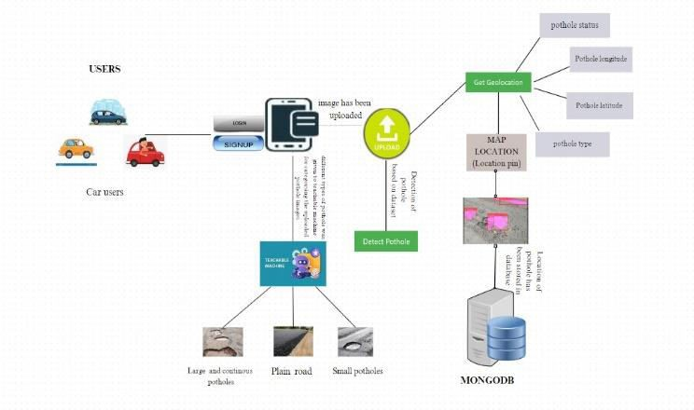

Fig 2: System Architecture

As shown in Fig. 2,to detect the pothole we collected a dataset which contains classes of some common type of potholes .The dataset includes 200 real-time images including training, testing and validation subsets. Here, they can view all reported potholes and take necessary action to address them promptly. By having access to this information, authorities can efficiently prioritize and allocate resources for pothole repairs, ultimately contributing to safer roads for everyone All data, including user accounts, pothole reports, and their statuses, is safely kept in MongoDB, a dependable database system. This ensures that information is organized and readily available when needed. By centralizing this data, the system allows for more effective coordination between users and authorities, ensuring that reported potholes are filled in a timely way.

Overall, our solution intends to simplify the pothole reporting and repair procedure, hence improving road safety and infrastructure maintenance efforts. An identification is made using CNN model to detect skin pothole in images. By evaluating the trained model with custom dataset, it results in detecting identification of pothole and reporting the pothole and the updating the status of the pothole.

**IV. RESULTS**

When the user login to account and uploaded the image of the pothole and by clicking the get geo location button and detect pothole button it will displays the as shown below fig 3 by containing pothole latitude and longitude, pothole status and type of pothole means small (or) large (or) medium pothole.

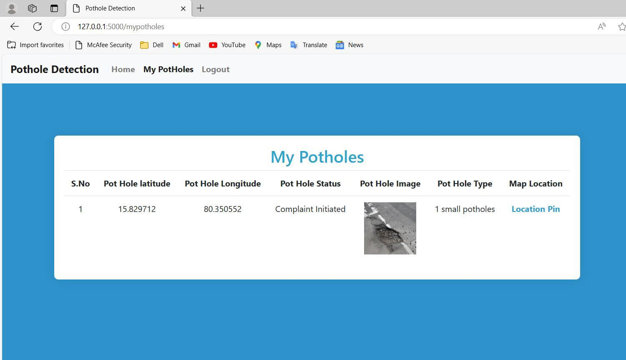

Fig 3: My potholes:Report status and location overview.

When the user clicks on the locate pin then it shows the following fig 4 by pinning the location in the map through this we can detect easily the location and avoid the rededency. This information is then send to a central server or platform where it is processed and analyzed.

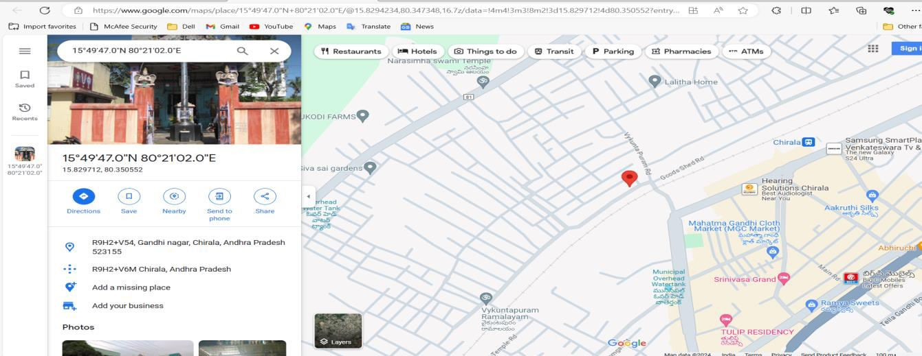

fig 5: pothole location on map**.**

When the authority login the page and then updating the status of the pothole as shown in the below fig 6 . this update is very useful for which pothole is alive and which is recovered

This update will done by the authorites only because of reducing frods

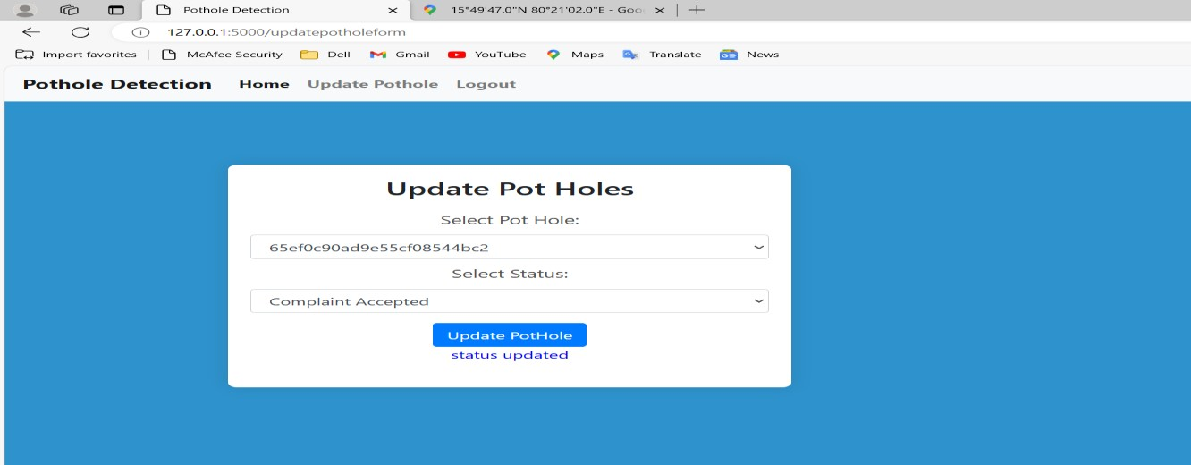

Fig 6: Updating the status of potholes.

The user can check the pothole which is uploaded has been complaint accepted or not which was updated by the authority

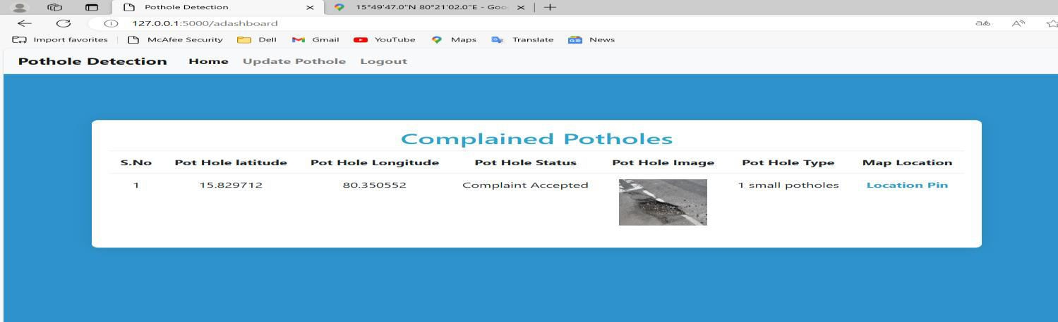

Fig 7: Complaint Accepted by Authorities

**V. CONCLUSION AND FUTURE WORK**

Primary identification of potholes is critical for road safety and maintenance. Our methodology effectively categorizes and locates potholes, allowing for timely repairs and preventing accidents. The use of modern object detection models such as SSD and Faster CNN ensures great accuracy in pothole detection. Our approach meets the demands of all road users by offering a quick option for reporting and repairing potholes without relying solely on authorities. Looking ahead, we intend to enhance our technology to detect a broader range of road problems and add capabilities such as online reporting and repair progress tracking, thereby improving overall road infrastructure management.

**REFERENCES**

1. Shubhra Rao Kuthyar,Roopashree S,Rasika V,Sahana Manjesh,Priyadarshini S,Department of Computer Science Engineering,Dayananda Sagar University Bengaluru, India;"An Intelligent Pothole Detection and Alerting System using Mobile Sensors and Deep Learning";2021 IEEE 18th India Council International Ganesh Babu R,Chellaswamy C,Surya Bhupal Rao M,Saravanan M,Department of Electronics and Communication Engineering;"Deep Learning Based Pothole Detection and Reporting System";
2. Ganesh Babu R,Chellaswamy C,Surya Bhupal Rao M,Saravanan M,Department of Electronics and Communication Engineering;"Deep Learning Based Pothole Detection and Reporting System"; IEEE 7thInternational Conference on Smart Structures and Systems ICSSS 2020.
3. Ping Ping,Xiaohui Yang:College of Computer and Information, Hohai University, Nanjing, China,Zeyu Gao: College of Engineering, San Jose State University, San Jose, USA;"A Deep Learning Approach for Street Pothole Detection";2020 IEEE Sixth International Conference on Big Data Computing Service and Applications (BigDataService).
4. Shebin Silvister,Dheeraj Komandur,Shubham Kokate,Aditya Khochare,Dr. Vishwanath Karad MIT World Peace University Pune, India;"Deep Learning Approach to Detect Potholes in Real-Time using Smartphone";2019 IEEE Pune Section International Conference (PuneCon) MIT World Peace University, Pune, India. Dec 18-20, 2019.
5. Muhammad Haroon Yousaf,Muhammad Obaid Ullah,Muhammad Haroon Asad ,Saran Khaliq ,Swarm Robotics Lab, National Centre of Robotics and Automation, Rawalpindi, Pakistan;"Pothole Detection Using Deep Learning:

A Real-Time and AI-on-the-Edge Perspective";Hindawi Advances in Civil EngineeringVolume 2022, Article ID 9221211.Anas Al-Shaghouri, Rami Alkhatib, Samir Berjaou,Rafik Hairri University, Mechref- Chouf2010, Lebanon;"Real-Time Pothole Detection Using Deep Learning"LING-FANG LI, XU WANG, WEI-JIAN HU , NEAL N. XIONG YONG-XING DU , AND BAO-SHAN LI,"Deep Learning in Skin Disease Image Recognition: A Review",IEEE Access (Volume :8),2020.

1. Dr.M. Seetha ,Professor, Department of CSE, GNITS, Hyderabad, Telangana, India and Dr. K. Prasanna,Associate

Professor, Department of CSE, GNITS, Hyderabad, Telangana, India;"Intelligent Deep Learning Based Pothole Detection and Alerting System";International Journal of Computational Intelligence Research ISSN 0973-1873 Volume 19.Ahmed A. Elngar , Rishabh Kumar , Amber Hayat , Prathamesh Churi,"Intelligent System for Skin Disease Prediction using Machine Learning",CONSILIO 2021.

1. Anas Al-Shaghouri, Rami Alkhatib, Samir Berjaou,Rafik Hairri University, Mechref- Chouf2010, Lebanon;"RealTime Pothole Detection Using Deep Learning"
2. Yeoh Keng Yik, Nurul Ezaila Alias, Yusmeeraz Yusof and Suhaila Isaak,Division of Electronic and Computer Engineering and Environmental Engineering, Faculty of Engineering, Universiti Teknologi Malaysia, 81310 Johor Bahru, Johor, Malaysia;
3. Prof.Arunadevi Khaple(Professor), Shubham Barangule(Student), Nandakishor More(Student),Omkar Mote(Student), Abhishek Doke(Student)Computer Department Zeal Collage of Engineering and Research, Pune, Maharashtra, India;"POTHOLE DETECTION AND COMPLAINT MANAGEMENT SYSTEM USING DEEP

LEARNING"; ISSN: 2456-4184 ,Volume 8, Issue :5 May 2023.

1. Aparna , Yukti Bhatia, Rachna Rai , Varun Gupta,Department of Computer Science and Engineering, Chandigarh College of Engineering and Technology, India, Naveen Aggarwal,UIET, Panjab University, Chandigarh,

India;"Convolutional neural networks based potholes detection using thermal imaging";Journal of King Saud University - Computer and Information Sciences

1. Kunal Chawla,Vanshika Kaul,Cse-AI &ML, Chandigarh University,Mathura, India.Parth Thakkar,Shiv Sahil Soni,Cse- AI & ML, Chandigarh,UniversityNew Delhi, India;"StreetSafe: AI-Based Android Application for Pothole Detection";Volume 11, Issue 4 April 2023,(pp-578-588)
2. Harun Joe,Joseph Blessingh, Joel Cherian,Student, Dept. of Computer Engineering, Fr. C. Rodrigues Institute of Technology, Vashi, Maharashtra, India;"An Intelligent Pothole Detection System using Deep Learning";Volume: 07, Issue: 02 ,Feb 2020.
3. Prof.Arunadevi Khaple(Professor), Shubham Barangule(Student), Nandakishor More(Student),Omkar

Mote(Student), Abhishek Doke(Student),Computer Department ,Zeal Collage of Engineering and Research, Pune, Maharashtra, India;"SURVEY ON POTHOLE DETECTION AND COMPLAINT MANAGEMENT SYSTEM USING DEEP LEARNING";ISSN: 2456-4184 ,Volume 8, Issue 5 May 2023.

1. Mr K. Krishna Reddy(Assistant professor),Tuniki Bhavana(Ug scholar),Bandyala Tejaswini(Ug scholar), P. Mallesh(Ug scholar),Adepu sharath(Ug scholar), Dept of CSE, Sreyas Institute of Engineering and Technology, Telangana, India;"A Deep Learning Approach For Pothole Detection".
2. Shylee Veronica, Poojashree C, Himangshu Das, Mangesh Thakur Guided by Dr. Mallikarjun K, Director of School of Computing and Information Technology ,REVA UniversityBengaluru, India;"Pothole Detection System".
3. Rupsha Debnath, Sayandeep Dutta, Dr. Sangita Roy, Arpita Santra,Narula Institute of Technology, Kolkata, West Bengal;"Real Time Pothole Detection with Deep Learning and Arduino";International Journal of Research Publication and Reviews, Vol 4, no 6, pp 2787-2790 June 2023.

7.521

INTERNATIONAL JOURNAL OF



I

m

p

ac

t

F

a

c

t

o

r



[www.ijmrset.co](http://www.ijmrset.com/)

[m](http://www.ijmrset.com/)

MULTIDISCIPLINARY RESEARCH

**IN SCIENCE, ENGINEERING AND TECHNOLOGY**

**| Mobile No: +91-6381907438 | Whatsapp: +91-6381907438 | ijmrset@gmail.com |**



***(***

***A Monthly, Peer Reviewed, Referred, Multidisciplinary, Scholarly Indexed, High***

***Impact Factor, Open Access Journal - ISO-9001-2007 Certified)***

**D**

**e**

**epth**

**i**

**Ka**

**nka**

**na**

**l**

**a**



**The Board of IJMRSET is hereby awarding this certificate to**

**B.Tech Student, Department of CSE, KKR & KSR Institute of**

**Technology and Sciences, A.P, India**

**In Recognition of publication of the paper entitled**

**“**

**A GPS and Machine Learning Driven Approach to**

**Pothole Detection and Reporting System**

**”**

**Published in IJMRSET, Volume 7, Issue 3**

**,**

**March**

**202**

**4**



***(***

***A Monthly, Peer Reviewed, Referred, Multidisciplinary, Scholarly Indexed, High***

***Impact Factor, Open Access Journal - ISO-9001-2007 Certified)***

**L**

**ak**

**sh**

**mi**

**Trip**

**u**

**ra M**

**an**

**na**

**v**

**a**



**The Board of IJMRSET is hereby awarding this certificate to**

**B.Tech Student, Department of CSE, KKR & KSR Institute of**

**Technology and Sciences, A.P, India**

**In Recognition of publication of the paper entitled**

**“**

**A GPS and Machine Learning Driven Approach to**

**Pothole Detection and Reporting System**

**”**

**Published in IJMRSET, Volume 7, Issue 3**

**,**

**March**

**202**

**4**



***(***

***A Monthly, Peer Reviewed, Referred, Multidisciplinary, Scholarly Indexed, High***

***Impact Factor, Open Access Journal - ISO-9001-2007 Certified)***

**V**

**e**

**nk**

**ata**

**Sh**

**i**

**v**

**a**

**ni**

**Ka**

**r**

**ana**

**m**



**The Board of IJMRSET is hereby awarding this certificate to**

**B.Tech Student, Department of CSE, KKR & KSR Institute of Technology**

**and Sciences, A.P, India**

**In Recognition of publication of the paper entitled**

**“**

**A GPS and Machine Learning Driven Approach to**

**Pothole Detection and Reporting System**

**”**

**Published in IJMRSET, Volume 7, Issue 3**

**,**

**March**

**202**

**4**



***(***

***A Monthly, Peer Reviewed, Referred, Multidisciplinary, Scholarly Indexed, High***

***Impact Factor, Open Access Journal - ISO-9001-2007 Certified)***

**Si**

**v**

**ani**

**Le**

**kk**

**al**

**a**



**The Board of IJMRSET is hereby awarding this certificate to**

**B.Tech Student, Department of CSE, KKR & KSR Institute of**

**Technology and Sciences, A.P, India**

**In Recognition of publication of the paper entitled**

**“**

**A GPS and Machine Learning Driven Approach to**

**Pothole Detection and Reporting System**

**”**

**Published in IJMRSET, Volume 7, Issue 3**

**,**

**March**

**202**

**4**



***(***

***A Monthly, Peer Reviewed, Referred, Multidisciplinary, Scholarly Indexed, High***

***Impact Factor, Open Access Journal - ISO-9001-2007 Certified)***

**S.**

**V**

**i**

**j**

**aya**

**La**

**ksh**

**mi**



**The Board of IJMRSET is hereby awarding this certificate to**

**Assistant Professor, Department of CSE, KKR & KSR Institute of**

**Technology and Sciences, A.P, India**

**In Recognition of publication of the paper entitled**

**“**

**A GPS and Machine Learning Driven Approach to**

**Pothole Detection and Reporting System**

**”**

**Published in IJMRSET, Volume 7, Issue 3**

**,**

**March**

**202**

**4**



student of the CSE department,

**KKR & KSR Institute of Technology and Sciences**

,

Guntur, Andhra Pradesh, has worked as an

**Engineering Intern**

on AI/IoT/Blockchain

Technology in the

**corporate engineering team**

from

**December 18th to April 18th 2024.**

Intern ID:

**MS2024-162**

Roll No:

**20**

**JR**

**1A0566**

We wish you all the best for your future.



Mr./Ms. KANKANALA DEEPTHI

This is to certify that

**MADHU PARVATHANENI**

**INTERNSHIP CERTIFICATE**



student of the CSE department,

**KKR & KSR Institute of Technology and Sciences**

,

Guntur, Andhra Pradesh, has worked as an

**Engineering Intern**

on AI/IoT/Blockchain

Technology in the

**corporate engineering team**

from

**December 18th to April 18th 2024.**

Intern ID:

**MS2024-175**

Roll No:

**20**

**JR**

**1A0584**

We wish you all the best for your future.



Mr./Ms. MANNAVA LAKSHMI TRIPURA

This is to certify that

**MADHU PARVATHANENI**

**INTERNSHIP CERTIFICATE**



student of the CSE department,

**KKR & KSR Institute of Technology and Sciences**

,

Guntur, Andhra Pradesh, has worked as an

**Engineering Intern**

on AI/IoT/Blockchain

Technology in the

**corporate engineering team**

from

**December 18th to April 18th 2024.**

Intern ID:

**MS2024-163**

Roll No:

**20**

**JR**

**1A0567**

We wish you all the best for your future.



Mr./Ms. KARANAM VENKATA SHIVANI

This is to certify that

**MADHU PARVATHANENI**

**INTERNSHIP CERTIFICATE**



student of the CSE department,

**KKR & KSR Institute of Technology and Sciences**

,

Guntur, Andhra Pradesh, has worked as an

**Engineering Intern**

on AI/IoT/Blockchain

Technology in the

**corporate engineering team**

from

**December 18th to April 18th 2024.**

Intern ID:

**MS2024-172**

Roll No:

**20**

**JR**

**1A0580**

We wish you all the best for your future.



Mr./Ms. LEKKALA SIVANI

This is to certify that

**MADHU PARVATHANENI**

**INTERNSHIP CERTIFICATE**